Assignment - hide assignment grades and feedback until
ready for release to all students

MOODLE TRAINING

The default setting when creating an assignment drop box in your Brookes Moodle site is to release
the grades and feedback to students as soon as the tutor enters and saves the data.
Hide Grades and Feedback
- Open your Moodle course site. Click on Grades (listed in the SETTINGS menu to the
left of your screen). Check that editing is turned on.
- Select Simple view from the Gradebook drop down list.
- Navigate to the assignment you wish to hide grades on. Scroll across to the Actions column.
- Click on the eye icon to hide grades until you are ready to release them. The assignment
title will be greyed out when you have hidden the grade as illustrated below.
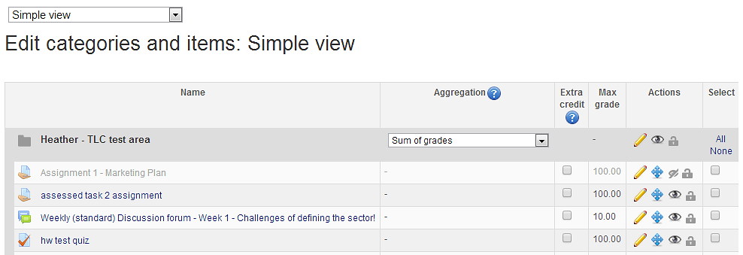
Click on the eye icon to hide grades

- Click on
Hide Feedback until ready for release
After the assignment submission deadline has passed, open your course site and turn editing on.
Navigate to the assignment drop box link on the course home page.
Click on the eye icon to hide the assignment link.
How to Release grades and feedback…
Open your Moodle course site and turn editing on. Follow instructions 1 – 3 above.
Click on the closed eye icon to unhide grades (item 4). Click on Save changes.

