Guide to using PhilPapers
Contents

Access Philpapers 1
Browse by a topic 2
Search by subject 5
Search by authors 6
Access article full text 7
Still need help? 8

Access Philpapers

Philpapers is a comprehensive index of philosophy books and articles. Search by subject or author, link to full text articles where available and download citations to EndNote.
Philpapers can be accessed via Philosophy Library webpage.
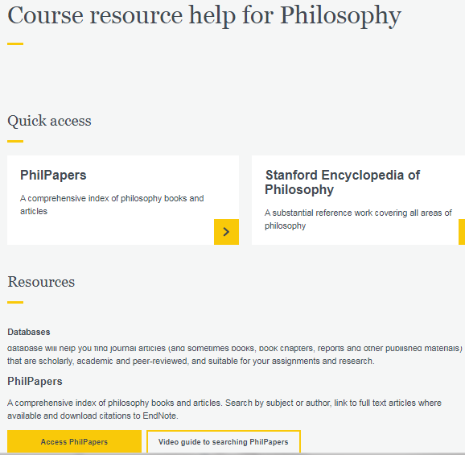
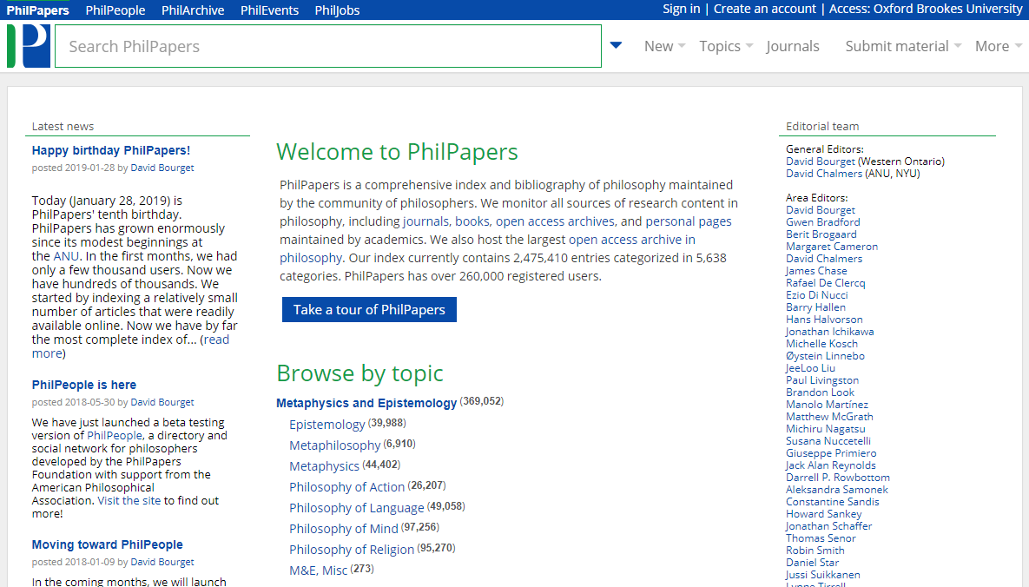

Browse by a topic

You can browse by a topic starting from a broad category.
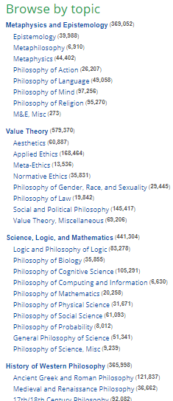
For example, you can select “Medieval and Renaissance Philosophy”.
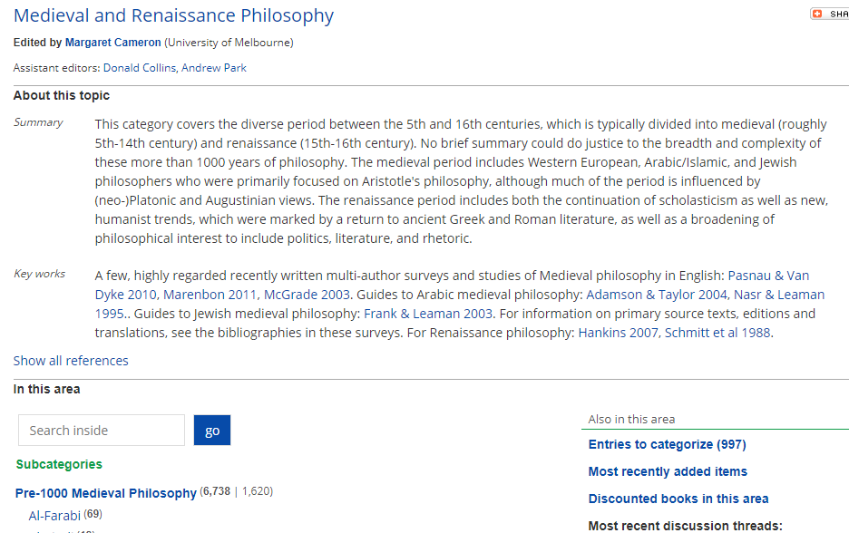
And then narrow down by browsing the “Subcategories”.
For example, you can select “John Duns Scotus”.
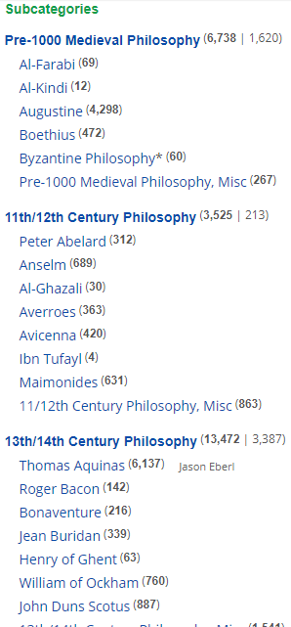
You can also search within a category.
For example, you can search for works on “causality” related to John Duns Scotus.
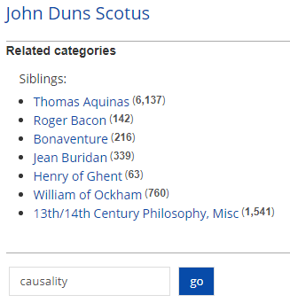
To read more information click on a title.
For example, “Duns Scotus on Autonomous Freedom and Divine Co-causality”.
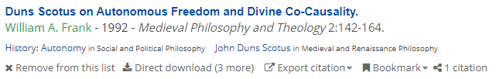
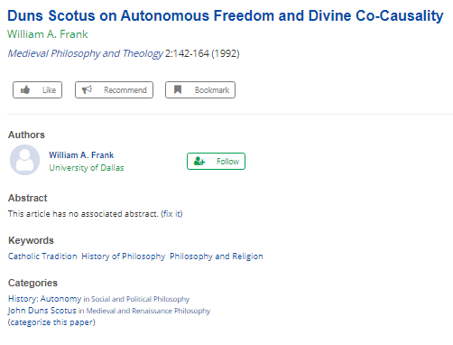

Search by subject
You can do a keyword search.
For example, “modularity of mind”.
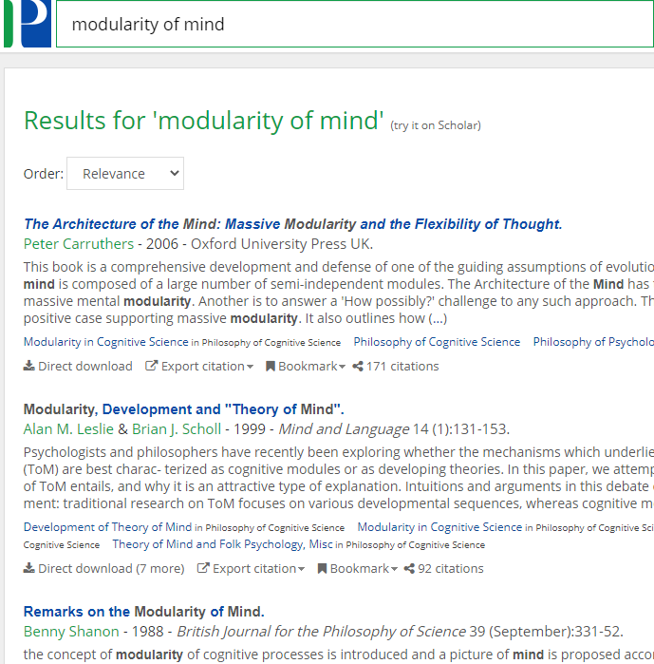

Search by authors

You can search by author for example “Helen de Cruz”.
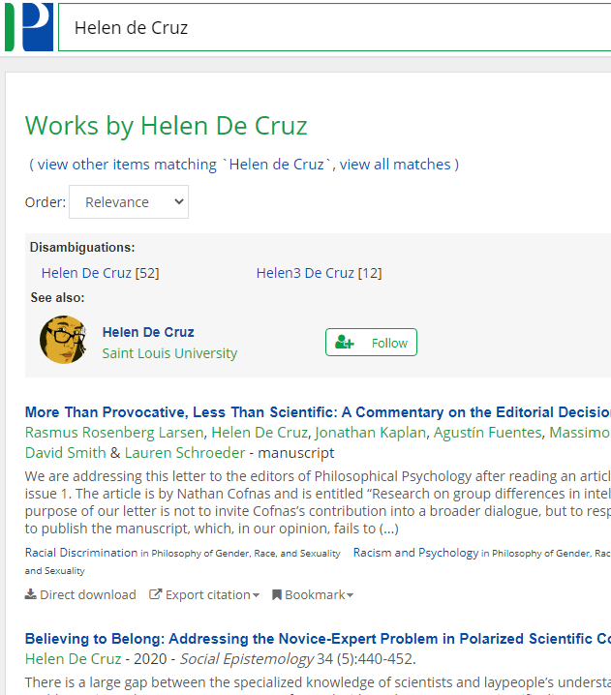

Access article full text

To check if the full text of the article is available you need to go to the “Download options” at the end of the article record.
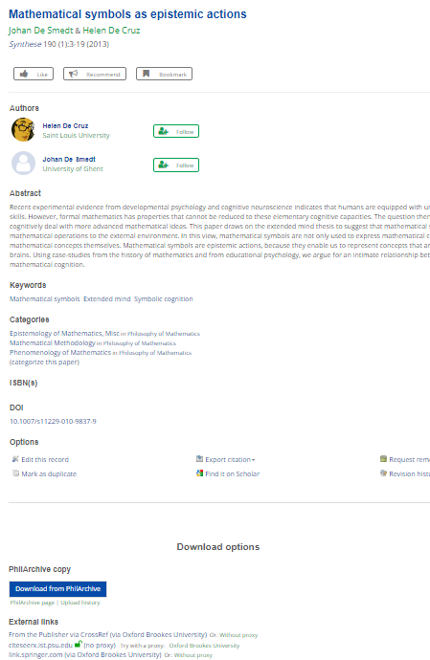

You can click the “Download from PhilArchive” if available.

Or if there is no archive copy you can click on “Find it @Oxford Brookes University”

Still need help?

The Academic Liaison Librarian for Philosophy is Ashley Cushman.
Ashley works hybrid, so sometimes at Headington, sometimes at Harcourt, and sometimes at home.
Email acushman@brookes.ac.uk if you have any questions.

