EndNote Online

Instructions on setup and use for Education & Early Childhood students
(Throughout this guide, numbered lists are sets of instructions; un-numbered bullet points are information. EndNote Online is sometimes called EndNote Web or EndNote Basic.)
For lots more detail about EndNote see the Library Web pages: http://www.brookes.ac.uk/library/how-to/use-endnote/

Create your account
- Go to https://access.clarivate.com/login?app=endnote and “Register”
- Give your Brookes email address and password (you may need to add a symbol to your password to meet EndNote’s password rules)
- Wait for the activation email to arrive in your Brookes inbox and click the activation link
- Go and log in to your new account at https://access.clarivate.com/login?app=endnote

Set up Roaming Access
Get access to the BrookesHarvard referencing style by setting up "roaming access". Follow the instructions below - it lasts for a year and then needs renewing. Instructions also at
http://www.brookes.ac.uk/library/how-to/use-endnote/

- Close EndNote and Word if open, then go to the Library home page
- Look for the LibrarySearch box and click on the 'Databases' tab.
- Click on the 'W' yellow box and then on 'Web of Science'.
- When you do this, the entry for Web of Science will be shown. Click on the blue link that says 'Search Collection Directly at the Provider'
- If prompted, sign in with your Brookes ID and password..
- Click on the 'Products' option on the black toolbar, top right, and select EndNote.
- You’ll then be returned to the EndNote Online sign in page. Sign back in with your email address and EndNote password. Choose the 'Options' tab and then 'Subscription' to check your roaming access has been activated.

Configure your default referencing style to be BrookesHarvardAllAuthors
This will save you having to comb through the hundreds of available referencing styles every time you want to put EndNote references into Word/Pages:
- In the top menu, click on Format then Bibliography.
- Next to the Bibliographic Style drop-down, click on Select Favorites (in blue)
- You’ll see a pair of boxes: All, on the left, lists hundreds of possible referencing styles, while My Favorites, on the right, will be blank.
- Scroll down the All list until you find BrookesHarvardAllAuthors. (You need this rather than BrookesHarvard, because Education programmes now require all authors listed for multiple-authored works.)
- Click on BrookesHarvardAllAuthors, then Copy to Favourites.
- No need to Save (as you’re not actually creating a bibliography now) - just move on to the next section.

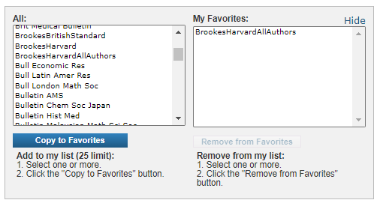

Configure your default import type
EndNote can import references from hundreds of databases using many different file types. However, LibrarySearch and all Education databases use the same file type, RefMan RIS, so you can save time by setting this as your default:
- In the top menu go to Collect, then Import References.
- Next to Import Option, click Select Favorites (in blue)
- You’ll see a pair of boxes: All, on the left, lists hundreds of possible import file types, while My Favorites, on the right, will be blank.
- Scroll down the All list till you find RefMan RIS, select it, then click Copy to Favourites.
- No need to do any Importing now, just move on to the next section.
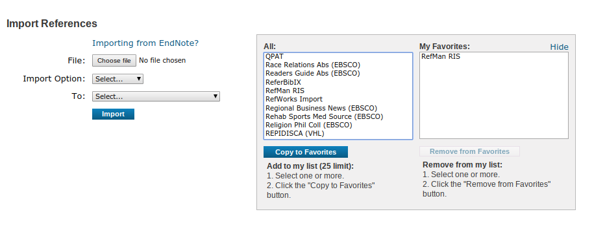

Install the Word plugin, Cite While You Write on your own device
To put references from EndNote into Word (or Apple Pages) on your own device, you need to install the Cite While You Write plugin. For full details of which versions of Word and which browsers are compatible with EndNote, see http://endnote.com/product-details/compatibility Note that EndNote does not work with Google Docs, though it will with LibreOffice and OpenOffice. (more information at http://www.brookes.ac.uk/library/how-to/use-endnote/ )

- Close down Word entirely on your device.
- In EndNote, choose the Format option from the tabs.
- Select “Cite While You Write plug-in”
- Choose the appropriate plug-in for Windows or Mac, download and follow the on-screen instructions. (Use the standard installation options.)
- Note that if using Chrome, to download you need to right-click and “Open link in new tab”.
- Once the plug-in is installed, relaunch Word and you should see an EndNote Online option displayed in the top toolbar. You may need to click on “Add-ins”.

Using EndNote Online on a Brookes networked PC: see page 5

Putting references into your EndNote Library
- You can add references to your Library manually or automatically.
- You can type in references, cut and paste…
- Or transfer from an electronic source, eg a database or LibrarySearch.

Adding a reference manually - quickest way to add a single item
- Click on the Collect tab and select New Reference
- This allows you to manually add a new reference, or copy and paste information.
- Select the reference type you want from the drop-down list of options and type the details of your reference into the relevant field/s.
- You can create Groups (like folders) to organise your references by topic. A reference can be in more than one group.
- EndNote automatically saves each field as you add information.

Adding references from LibrarySearch:
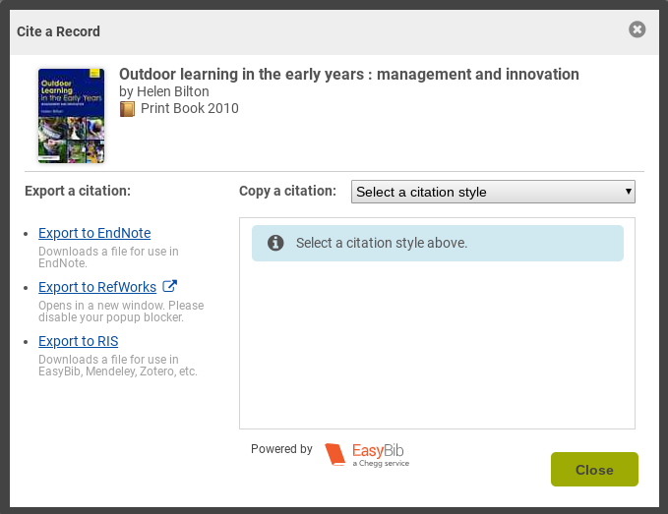
You can add a single item (though it may be just as quick to do this manually) or a whole set. This is a two-stage process: first you Export the file with your reference(s), then Import that to EndNote.

Single item:
- Do your search and find the item you want.
- Look for the “Cite, Share, Save” buttons on the right of the item and click Cite.
- In the Export a Citation box, click on Export to EndNote.
- Tell LibrarySearch where to save the file (eg in your Downloads), which is called citation.ris
- Once saved, you import the file to EndNote (see instructions below on Importing references)

Multiple items:
- Do your search, and select the items you want by clicking Save next to each one.
- Go into My Items (in the yellow bar at the top right of LibrarySearch) which should list everything you’ve just Saved.
- Click Cite and then Export to EndNote as for a single item, and follow 4 and 5 above.

Importing references:
Once you have chosen and saved a file of references (from LibrarySearch or any other database which uses .ris files) you need to import those references into your EndNote Online library.
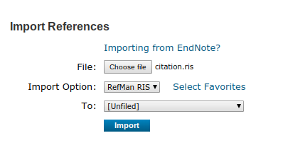
- Go into your EndNote Online account.
- In the top grey menu bar, select Collect and then mouse across to Import References.
- For File, choose the citation.ris file you saved.
- For Import Option, select RefMan RIS (this should already be in your favourites if you followed the Configure your default import type instructions above)
- For To, select where you want the references to go - into a Group (topic) if you already have them set up, or create a New Group, or just into [Unfiled]
- Then click Import and your new references will go into the place you selected.

For help with adding references from any databases which don’t use the .ris file type, there is help on the Library EndNote page: http://www.brookes.ac.uk/library/how-to/use-endnote/

Adding references from Ebsco Education databases:
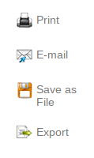
If you have done a search in British Education Index or any of our Ebsco education databases, and added the references you want to your folder in the database, you can export them to EndNote.

- Go into the folder (top right) and click the Export link on the right
- Choose Direct export to EndNote Web, then click Save (on the left).
- A new tab/window will open for you to log in to your EndNote account (even if you were logged in already - so you can end up logged in in multiple tabs!)
- You should then see “EBSCOhost Import Results” and the number of records imported. They’ll be in Unfiled, so go to “My References” and click on “Unfiled” to organise them into groups.

Organising your references:
- Use groups in EndNote to label sets of references, for example which assignment they’re for, or which chapter of a dissertation.
- References can belong to more than one group, and you can choose to share groups with other EndNote users.
- You can either put references straight into a group when manually adding or importing them, or click on any reference to edit it and scroll to “Groups” at the bottom.

Making your own study notes and saving PDFs in EndNote
You can make your own study notes in the “Research Notes” field of any reference in your EndNote library (click on the item title to do this). For example, a useful quote from the item and what page it’s on. You can also use the Attach Files option to add a PDF of the item.

Using EndNote Online with Word
There are two ways you can use EndNote Online to create bibliographies (reference lists) in your Word (or LibreOffice or OpenOffice) documents or Mac Pages (not in Google Docs):
- Create a “stand-alone” bibliography from a group of references, independent of any text
- Add citations to a Word document (e.g. essay or dissertation) which automatically creates a reference list at the end of the document

Creating a stand-alone bibliography:
- In EndNote Online, click on the Format tab and then Bibliography
- Use the drop-down menu to select which group you want to include (or All References).
- On the second drop-down menu, choose a referencing style – if you have set up BrookesHarvard as your default style you will just be offered this
- Choose the appropriate format for your bibliography (HTML, plain text, rich text) and save, email or preview-and-print this bibliography.

Adding citations to a Word document:
Once you have downloaded the Cite While You Write plugin (see above):
- Click at the point in your text where you want to insert a reference
- Go to the EndNote Online option in your Word toolbar and choose Insert Citations
- You will be asked to log in to your EndNote Online account again - may take several tries
- A search box will appear to find the reference you want (eg by author or keyword)
- Find and insert the reference. The full reference will then automatically appear in the reference list at the end of your document.
- To edit the in-text reference (eg to add page numbers), right-click on the reference, choose Edit Citation(s) and use the menu options that appear. (Don’t just overtype - this will be overwritten when the document saves.)

To use EndNote Online with Word on a Brookes student networked PC:
- Start EndNote (X9 or 20) from AppsAnywhere (ignore the option to link to your existing library)
- Start Word after EndNote
- In Word, click the “EndNote X9” (or X20) tab
- Choose Preferences, then Application, and change to EndNote Online
- You will be asked to fill in your EndNote login details again – may take several tries

More help using EndNote Online
- More help with using EndNote Online (Web/Basic) is available at
http://www.brookes.ac.uk/library/how-to/use-endnote/
- EndNote Online itself has detailed online help for you to use at http://www.myendnoteweb.com/help/en_us/ENW/help.htm
- Contact the Education Librarians if you still need more help: bit.ly/educlibhelp

