An introduction to EndNote Online

Section 1: About EndNote
EndNote Online is a service which allows you to collect, store and manage your own collection of references. It’s free to Brookes students and can be accessed from anywhere you have access to the internet

- EndNote allows you to create a database of references, known as a ‘Library’.
- You can add references manually or transfer them from many databases and library catalogues. Your EndNote Library will be fully searchable and you can annotate your references e.g. to add your own notes or keywords
- You can insert your EndNote references into Word documents in the form of citations and bibliographies, formatted in the style of your choice.
APA 7 is available on EndNote

EndNote desktop
There is also a software version of EndNote, also known as EndNote desktop, which has been installed on all university networked PCs and can also be used on personal laptops or pcs. You can transfer references between the two.

Library’s EndNote webpages - provide information on using all aspects of EndNote https://www.brookes.ac.uk/library/how-to/use-endnote/

Section 2: Setting up your EndNote Online Library

2.1 Create your EndNote Library account

The first step is to set up your EndNote Online account, or ‘Library’.
- Go directly to http://www.myendnoteweb.com/ OR, follow the link to EndNote Online on our help page at: https://www.brookes.ac.uk/library/how-to/use-endnote/
- On the EndNote home page, click on ‘Register’ link to the right of the login boxes (do not log in). Enter an email address to start the registration process. You’ll be prompted to choose a password for your EndNote account.

2.2 EndNote and ‘roaming access’

Once you have registered, you can access your EndNote account from anywhere through the links above. As a member of Brookes you can get access to added features such as additional storage space online through ‘roaming access’. When you first create your account, we recommend that you check whether you have roaming access activated:
- In EndNote select ‘Options’ from the top menu bar and then ‘Subscription’. If this indicates you have ‘Web of Science Roaming’ access for a year, you don’t need to do anything further.
- To activate roaming access, sign out of your EndNote account using the option at the top right of the screen. Go to the Web of Science database via the library homepage.
- Log in with your Brookes login details. On the black toolbar, top right of screen, select Products and EndNote Online. Log into your EndNote account. You should now have roaming access.

Section 3: Building your EndNote Library
You can add references to your Library manually or transfer references and PDFs from an electronic resource such as a database, library search option or catalogue.

3.1 Adding a reference manually

- In EndNote, click on the Collect tab and select New Reference
- Select the reference type you require from the drop-down list of options e.g. book/journal article/web page.
- Type the details of your reference into the relevant fields. EndNote automatically saves each field as you add information. Tip: If copying from Word, EndNote may copy the formatting of the text. Copying text from Notepad or WordPad will work better.
- If you scroll down the screen you will see a number of other fields you can fill in, e.g. Keywords; Name of Database; Notes.

3.2 Transferring references from LibrarySearch

One way to add references to your Library is to export them from LibrarySearch on the Library home page. Follow the steps below:
- Transfer a single reference by clicking on the 'Cite' option next to the record details and then click on 'Export to EndNote'.
- Transfer a batch of references by clicking on the 'Save' option to the right of each. Click on ‘My items’ top right once you’ve finished selecting. On the 'My items' screen click on the 'Cite' option above the list of references. Click on 'Export to EndNote'.
- This will download the file to your PC.
- To import the saved file, go to your EndNote library. Hover over the Collect tab and click on the option marked Import references
- Click on Choose and select the file that has been downloaded
- For Import option, select RefMan RIS from the drop-down list. You will have to scroll down the list quite a way to see RefMan RIS
- Select the group in your library you'd like the reference to go into. If you haven't made any groups (folders, if effect), just added to Unfiled. Click Import.

3.3 Adding references from databases

Many databases allow you to transfer references into EndNote via an import or direct export feature. You can also save PDFs and store them in EndNote with the relevant reference – a handy way to keep all your research together.
Check our EndNote help page at https://www.brookes.ac.uk/library/how-to/use-endnote/ in the section on ‘adding references’ to see if the database works with EndNote and what you need to do.

Both PsycINFO and Web of Science have an export option with instructions given under ‘adding references’ and then ‘adding references from databases’.

Exporting references from PsycINFO
- You can connect to PsycINFO from the psychology course resource help webpage https://www.brookes.ac.uk/library/resources-and-services/course-resource-help/psychology.
- Do a search and select the results you want to export by clicking on the folder icon next to each.
- Click on the open folder, top right of page to view selected references.
- Export. On the ‘Folder contents’ page, select the references you want to export and click the Export’ option on the right hand side. Select ‘Direct Export to EndNote Web’ and click ‘save’.
- Log into EndNote if prompted to do so. In EndNote, select ‘My references’ and they will be in the ‘unfiled’ folder. Check they have been exported correctly - you can amend/add information as needed.

Exporting references from Web of Science
- You can connect to Web of Science from the psychology course resource help webpage https://www.brookes.ac.uk/library/resources-and-services/course-resource-help/psychology
- Do a search and select the results you want to export by clicking in the box next to each abstract.
- Click ‘Export’. You will be prompted to log into your EndNote account
- Your newly added references should be in the ‘Unfiled’ folder. Check they have been exported correctly - you can amend/add information as needed.

Transferring PDFs into your Library
EndNote enables the storage of full-text files like PDFs. Unlimited file storage space is provided free of charge, as long as roaming access is enabled.
- In EndNote search to find the reference you wish to attach a pdf to.
- Click on the Title to open up the full citation.
- Scroll down to the section ‘Attachments’. Click on the paperclip icon.
- Click on the ‘Choose File’ button and locate the file you wish to upload.
- Click the ‘Upload’ button to transfer a copy of the file to EndNote.

3.4 Organising your references into groups

EndNote allows you to organise your references into groups of your choice. References can belong to more than one group. You can share groups with other EndNote users (read only or read and write).

To create a group, click in the check box next to the reference(s) you wish to add. Use the drop-down menu above the list of references to create a new group

To add references to an existing group, click in the check box next to the reference(s). Use the drop-down menu above the list of references to add these references to the group. You can add references to more than one group if you wish.

To share a group with another EndNote user, click on the ‘Organize tab’ and select ‘Manage My Groups’. Click on the ‘Manage Sharing’ button. Select ‘read only’ or ‘read and write’, as appropriate.

3.5 Searching for references

To display all your references, click on the ‘My References’ tab. Use the Quick Search box to search through all of your references or those in specific groups.
You can create a temporary list by selecting individual records and clicking on the ‘Copy to Quick List’ button.

3.6 Finding duplicate references

Click on the ‘Organize tab’ in your EndNote Online toolbar. Select ‘Duplicates’. Any duplicate references ae listed and you can delete as required.

Section 4. Using EndNote with Word
References in your EndNote Library can be added to a Word document, formatted in the style of your choice. The Psychology Department use APA 6.

4.1 Adding citations and a bibliography in Word
You can use EndNote to add citations to a Word document and create a bibliography at the end, with all the references formatted in APA 7. First you need to ensure you have the EndNote toolbar that allows Word and EndNote to interact:

4.2 Getting the EndNote toolbar on your own computer
You need to download the ‘Cite While You Write plug-in’ from EndNote. This sets up the connection between Word and EndNote:
- In EndNote choose the Format option from the tabs
- Select the ‘Cite While You Write plug-in’ and follow the on-screen instructions. Once you have installed the plug-in you should find that when you go into Word, the EndNote option will be displayed in the top toolbar

4.3 Getting the EndNote Basic toolbar on pooled room PCs
On pooled room PCs, both desktop and web versions of EndNote are available, so you need to make sure Word is pointing to EndNote Online (also known as online)

- Open up Word.
- Click on the EndNote option in the top toolbar to display the EndNote toolbar. Click on ‘Preferences’ in the Tools box.
- Click on the ‘Application tab’ in the dialog box.
- Select ‘EndNote online’. You'll be prompted to type in your EndNote account details (email address and account password).
- The EndNote option in the top toolbar should now say EndNote.

4.4 Inserting references

- First check that the style you want is the one displaying in the EndNote toolbar. Use the drop-down menu to browse and select styles – use APA 7
- Position the cursor in the text where you would like to place your next citation – make sure you add a space after the last word of text. From the EndNote toolbar, choose Insert Citations
- A new window will appear, as below. Enter a search term to look up the reference in your EndNote Library. From the results, highlight the reference you want and click ‘Insert’.
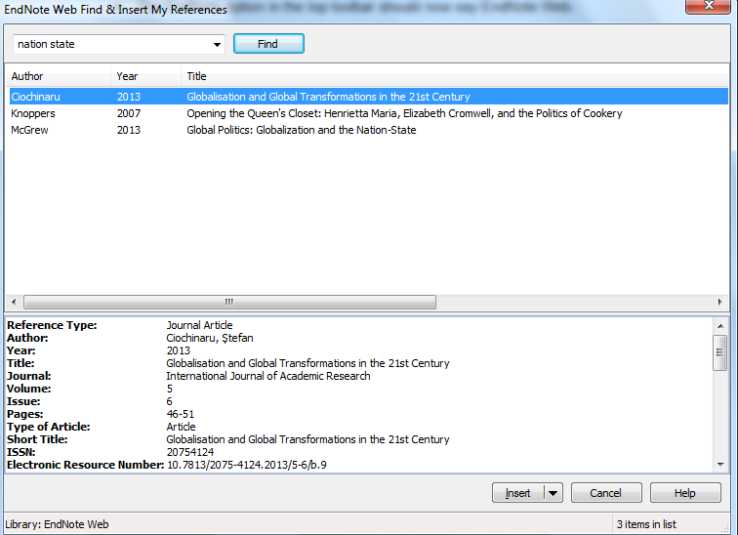

The citation will appear in the text of your document and as a bibliography at the end. These should be formatted in the style you have selected. Continue adding further references. These are added to your alphabetical bibliography in the correct place.

4.5 Creating a stand-alone bibliography

If you just want a list of references, you can use EndNote to create a stand-alone bibliography. In your EndNote Library click on the ‘Format’ tab and Bibliography’.

- Use the first drop-down menu to select which references you want to include (specific group, ‘Quick List’, or all of your references).
- From the second drop-down menu select a bibliographic style. Select ‘APA 6’.
- You can then choose the appropriate format for your bibliography (HTML, plain text, rich text) and can save, email or preview and print this bibliography.

Further help

More help is available at www.tinyurl.com/lr-endnote
Contact your Librarian, Helen Whittaker, hkwhittaker@brookes.ac.uk
You can also contact or EndNote email at lr-endnote@brookes.ac.uk

Updated 07/21

