Finding journals and journal articles for History
Journals are extremely important sources of scholarly writing; they contain the latest research, scholarship and thinking within a subject area. Articles in journals tend to focus on specific aspects of a subject in much more detail and often cover topics that will not be written about elsewhere. The Library provides a large range of History journals online (and a few available only in print). You will have references to journals in your reading lists and you will also need to find journal articles on a topic.

When you find a reference to a journal article, it will look something like this :

Roberts P., 'Royal Authority and Justice during the French Religious Wars', Past and Present, 184 (2004), 3-32

This is what each element of the reference means :
Roberts P | the author of the journal article
'Royal Authority and Justice during the French Religious Wars' | the title of the journal article
Past and Present | the title of the journal in which the article appears
184 | the volume number
2004 | the date of the journal issue in which the article appears
3-32 | the page numbers

Finding journal articles - following up references to specific articles
From the Library web pages select the Librarysearch tab.
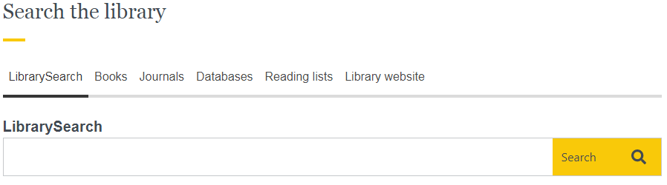

In the search box type in the details of the article (the title, plus the author’s surname).
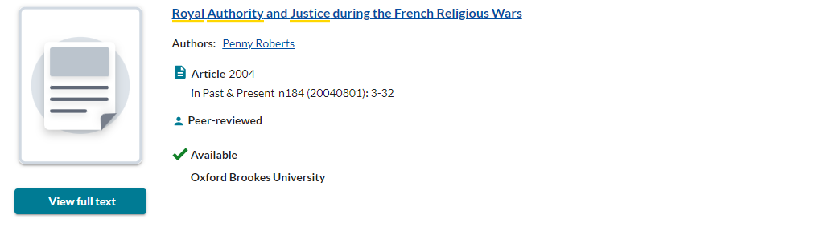

Click on view full text to see an electronic version of the article. The print holdings of the journal are shown below the green button (if available) should you prefer to photocopy the article.

Accessing e-journals
Please try to use links from the Library’s web pages to access our e-resources, as these links may contain additional information which makes accessing that content a much simpler process. Most of the Library’s databases and e-journals will simply prompt you to log in with your Brookes ID and password and once you have logged in you will be able to move to other databases or e-journals without the requirement to log in again during your session.

Which print journals are available from the Library?
From the Library web pages select journal titles and type the name of the journal into the search box. Click go.

Note down the call number as this tells you where the journal is on the shelves. Also check the year you want to consult is held.

The print journals are in the Journals area of the Basement of the Headington Library, arranged by call number.
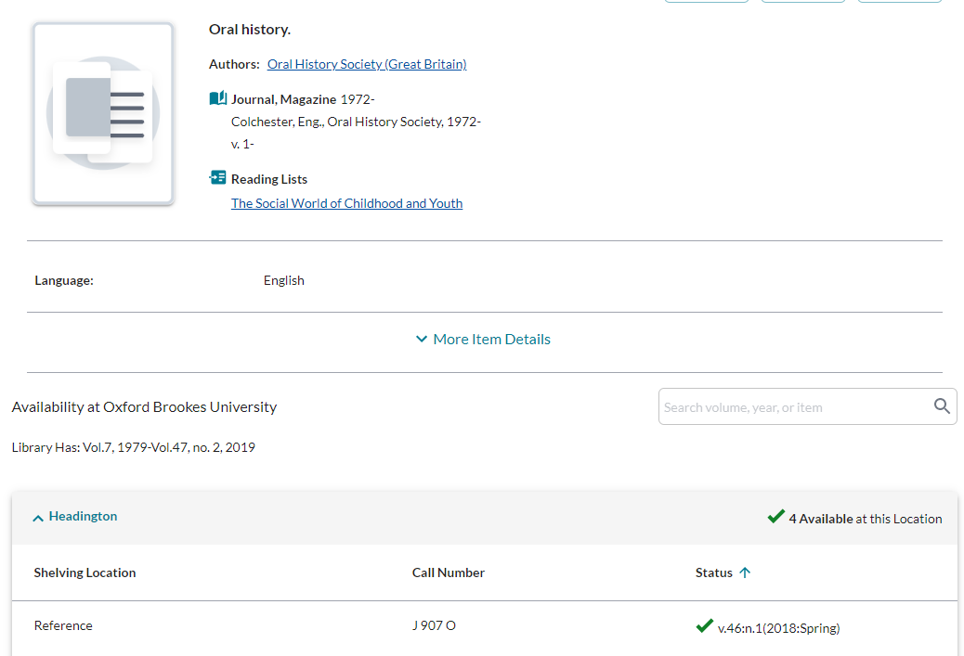

How do I find out what journal articles have been written on my subject?
To find articles on a particular topic or within a certain journal, you can use LibrarySearch or one of the Library’s wide range of online databases. You can get access to these databases from the library’s History web pages.

You can search by keywords or subject headings to find references to publications on your topic. Some databases give you direct access to e-journal articles. Other databases will provide you with a list of references to then follow up separately.

Which database should I use?

Historical Abstracts – covers the history of the world from 1450 to the present (excluding the United States and Canada), indexing articles, books and other publications from 1950 onwards; contains quite extensive abstracts for most entries; and links to some e-journal articles.

JSTOR - provides an archive of full text articles from a range of academic journals. Most journals covered do not give access to issues which are less than 3-5 years old.

BBIH - Bibliography of British and Irish History – highly recommended, comprehensive database providing bibliographic details of historical writing dealing with the British Isles, and with the British Empire and Commonwealth, from 55BC to the present. It lists books, articles in books and articles in journals.

How do I obtain articles from journals not available from the Library?

Copies of journal articles not available in print or online from the Library can be requested via the Interlibrary loan service.

More information
There is lots of guidance available on the History course resource help webpage or you can contact your History Librarian, Ashley Cushman, at acushman@brookes.ac.uk .

23 August 2022

