Twitter

- Users must be registered to send tweets but can read tweets without registering.
- Tweets are limited to 140 characters.
- Users can follow other users or follow a hashtag # identifying a certain topic.
- Users can post an individual tweet, reply to another user’s tweet, favourite or retweet posted tweets.
- Users can add photos, videos or links.
- There are various levels of privacy setting that users can select.

Engaging Productively in Online Communities at Brookes
- selecting and using appropriate communication technologies for group work
- knowing when and how to maintain appropriate levels of privacy in drafting and publishing to individuals and groups
- effectively managing group interactions using multiple technologies
- selecting and using technologies to represent and synthesise individual and group knowledge/learning
- communicating effectively online[1]
- developing fluency and command of ‘voice’ in online authoring and publishing
[1] (where the combination ‘effectiveness’ and ‘being online’ is likely to be defined by the professional context, e.g. perhaps in some disciplines at some levels maintaining active membership of professional groupings using email is appropriate, while in other disciplines and levels one might expect collaborative document authoring using advanced design tools)
Ref: ‘A Taxonomomy of Digital and Information Literacies’- https://wiki.brookes.ac.uk/display/GAA/Digital+and+Information+Literacy

Instagram

- Primarily a photo and video sharing service.
- Users can follow other users
- Users take photos with their mobile phone and upload them through the Instagram app.
- Users are able to manipulate photos by adding digital filters and labels.
- Through Instagram Direct users can share photos only with specific users or groups of users.
- Users are able to comment on other users photos.

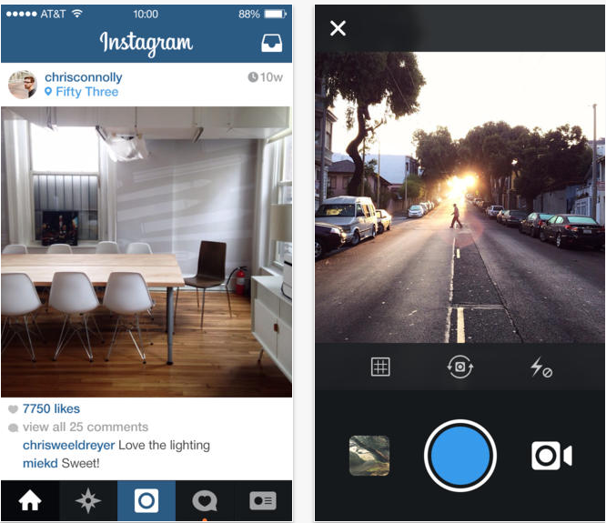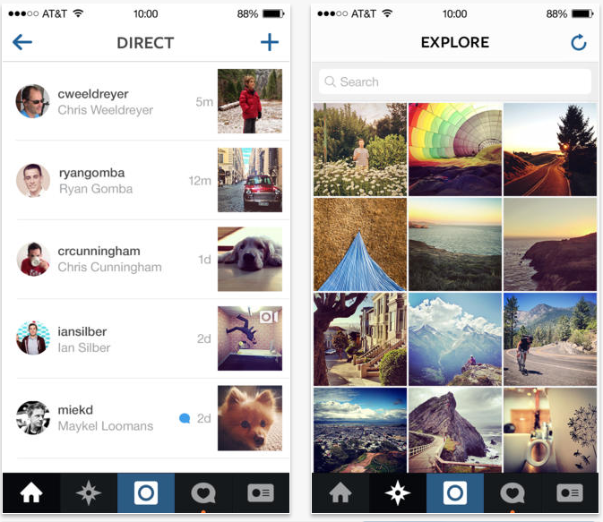

Engaging Productively in Online Communities at Brookes
- selecting and using appropriate communication technologies for group work
- knowing when and how to maintain appropriate levels of privacy in drafting and publishing to individuals and groups
- effectively managing group interactions using multiple technologies
- selecting and using technologies to represent and synthesise individual and group knowledge/learning
- communicating effectively online[1]
- developing fluency and command of ‘voice’ in online authoring and publishing
[1] (where the combination ‘effectiveness’ and ‘being online’ is likely to be defined by the professional context, e.g. perhaps in some disciplines at some levels maintaining active membership of professional groupings using email is appropriate, while in other disciplines and levels one might expect collaborative document authoring using advanced design tools)
Ref: ‘A Taxonomomy of Digital and Information Literacies’- https://wiki.brookes.ac.uk/display/GAA/Digital+and+Information+Literacy

Blogging

- Many different blogging platforms are available (Tumble and WordPress are the most popular).
- Blogs consist of discrete entries (or ‘posts’) that the user uploads to their blog.
- Blogs can be created and managed by individuals or groups (multi- author blogs).
- Most blogs are interactive, allowing other users to add comments message each other, this allows them to be seen as online communities.

Engaging Productively in Online Communities at Brookes
- selecting and using appropriate communication technologies for group work
- knowing when and how to maintain appropriate levels of privacy in drafting and publishing to individuals and groups
- effectively managing group interactions using multiple technologies
- selecting and using technologies to represent and synthesise individual and group knowledge/learning
- communicating effectively online[1]
- developing fluency and command of ‘voice’ in online authoring and publishing
[1] (where the combination ‘effectiveness’ and ‘being online’ is likely to be defined by the professional context, e.g. perhaps in some disciplines at some levels maintaining active membership of professional groupings using email is appropriate, while in other disciplines and levels one might expect collaborative document authoring using advanced design tools)
Ref: ‘A Taxonomomy of Digital and Information Literacies’- https://wiki.brookes.ac.uk/display/GAA/Digital+and+Information+Literacy

Moodle Forums

- Users must be enrolled on the module to be able to see and use that particular discussion board.
- Tutors or individual students can be set up as moderators.
- It is possible for tutors or students to grade forum posts.
- There are various subscription settings that can be selected. For example, you can push forum posts to enrolled students e-mail.

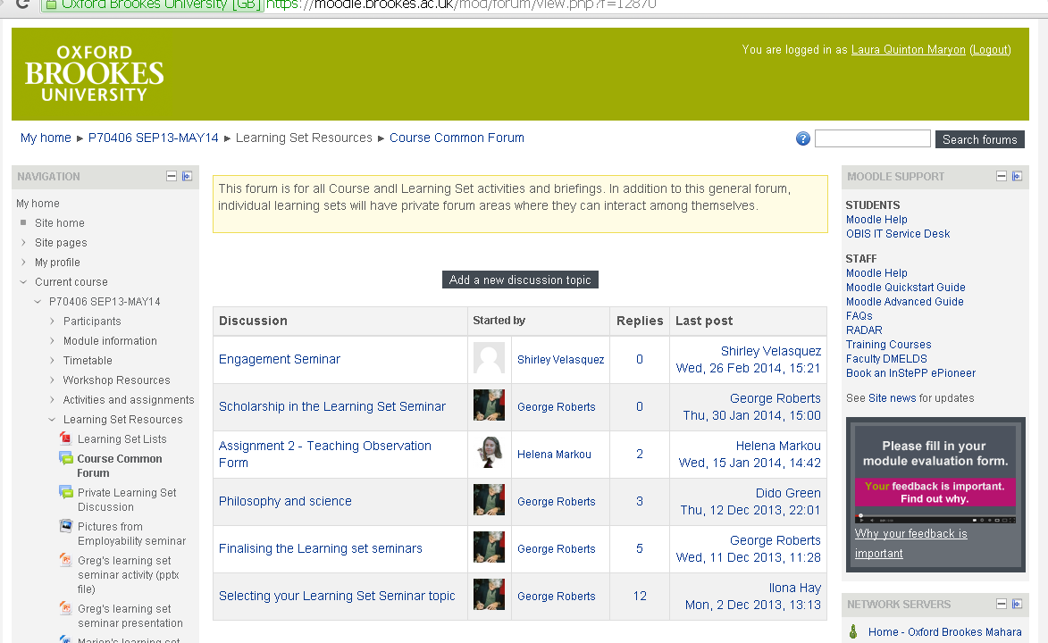

Engaging Productively in Online Communities at Brookes
- selecting and using appropriate communication technologies for group work
- knowing when and how to maintain appropriate levels of privacy in drafting and publishing to individuals and groups
- effectively managing group interactions using multiple technologies
- selecting and using technologies to represent and synthesise individual and group knowledge/learning
- communicating effectively online[1]
- developing fluency and command of ‘voice’ in online authoring and publishing
[1] (where the combination ‘effectiveness’ and ‘being online’ is likely to be defined by the professional context, e.g. perhaps in some disciplines at some levels maintaining active membership of professional groupings using email is appropriate, while in other disciplines and levels one might expect collaborative document authoring using advanced design tools)
Ref: ‘A Taxonomomy of Digital and Information Literacies’- https://wiki.brookes.ac.uk/display/GAA/Digital+and+Information+Literacy

Wikis

- A collection of articles that users can communally edit online.
- Text can be viewed and edited by anyone who enters the wiki.
- Many wikis have privacy settings so that only a certain group may edit and view the text.
- Brookes has its own wiki that students and tutors can use (requires Brookes login).

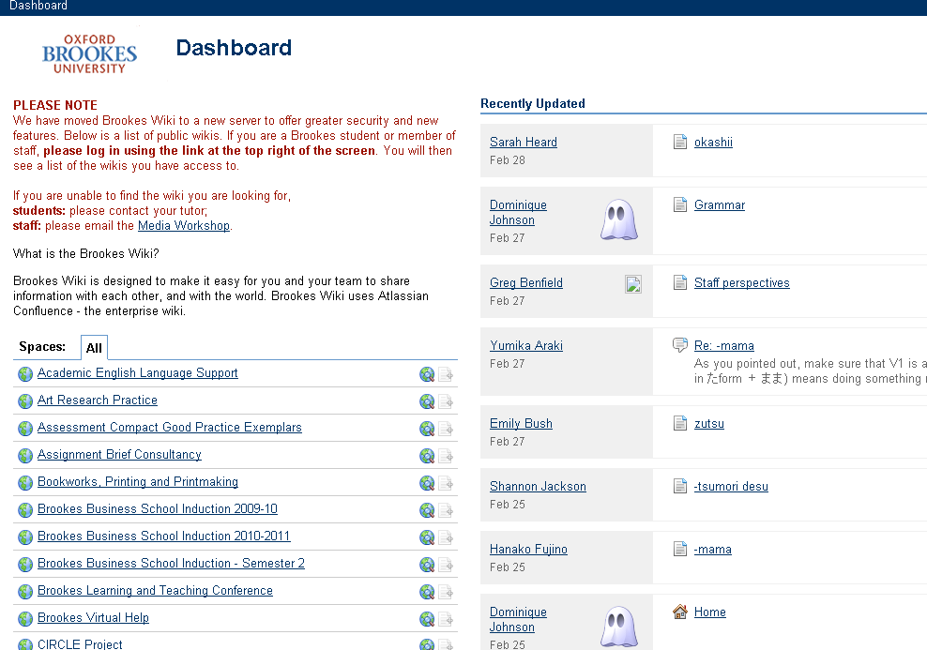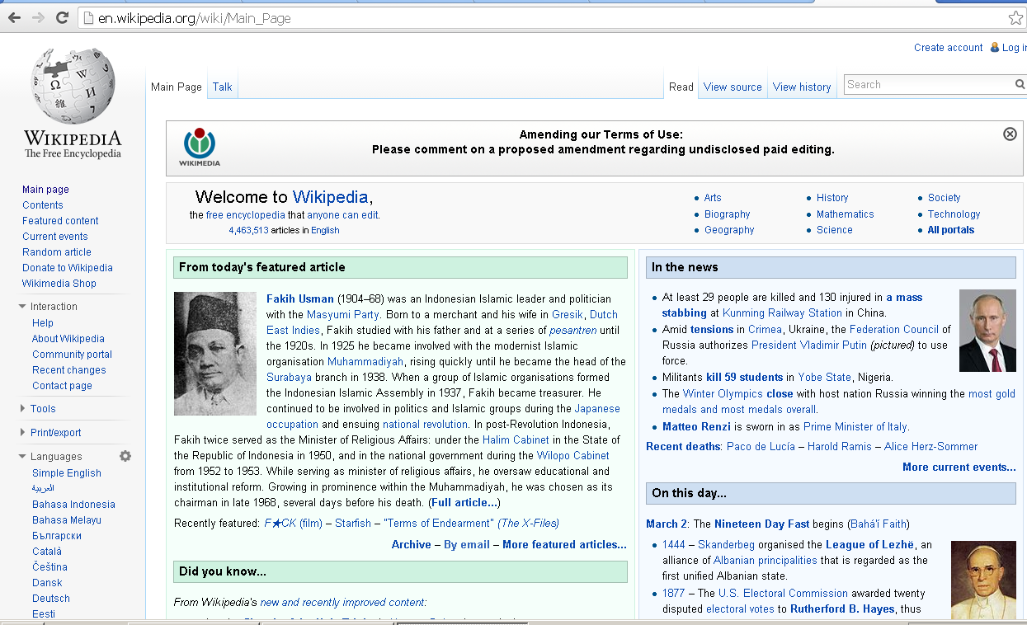

Engaging Productively in Online Communities at Brookes
- selecting and using appropriate communication technologies for group work
- knowing when and how to maintain appropriate levels of privacy in drafting and publishing to individuals and groups
- effectively managing group interactions using multiple technologies
- selecting and using technologies to represent and synthesise individual and group knowledge/learning
- communicating effectively online[1]
- developing fluency and command of ‘voice’ in online authoring and publishing
[1] (where the combination ‘effectiveness’ and ‘being online’ is likely to be defined by the professional context, e.g. perhaps in some disciplines at some levels maintaining active membership of professional groupings using email is appropriate, while in other disciplines and levels one might expect collaborative document authoring using advanced design tools)
Ref: ‘A Taxonomomy of Digital and Information Literacies’- https://wiki.brookes.ac.uk/display/GAA/Digital+and+Information+Literacy

