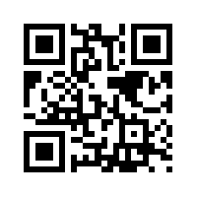Ebooks for Education students

Electronic books (ebooks) let you read the whole of a textbook on your computer screen. You can usually print or download limited numbers of pages, and sometimes download the whole book (usually for a limited time); some of our packages also let you add your own online notes to a book or make lists of your favourite ebooks.

How do I get access to them?
You’ll need your Brookes login details (student number and password) to log in when prompted.

If you want to look up a specific ebook:
- Go to the Library home page and choose Books and ebooks from LibrarySearch
- Search as you would for an ordinary printed book (eg author and keywords from the title)
- The results include both print and ebooks:
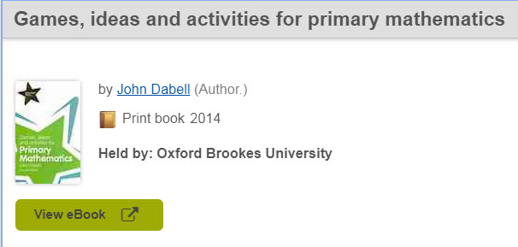If the book you want comes up as an ebook, click on the green View eBook button. (If prompted, log in with your Brookes details.) If you can’t see an ebook straight away, tick the “eBook” box in the Formats menu on the left. If there’s no “eBook” option there, then unfortunately we don't have that title as an ebook - feel free to suggest to the Education Librarians that we purchase an ebook version! (Not all titles are available as ebooks though.)

If you want to find ebooks on a particular topic:
- Do a keyword search on the Books and ebooks tab, such as “primary”, “teaching”, or “dyslexia”
- On the results list page, look at the menu on the left and select Oxford Brookes University from Library and eBook from All Formats.
- If you then get no results, there are no ebooks with those keywords in the title – try a slightly different, or broader, keyword search

If you want to browse to see what's available:

You can browse Education ebooks we hold in the following collections (all via Brookes Login):
- Dawsonera – go to http://bit.ly/dawsoneduc (selects Education ebooks we own)
- ProQuest – go to http://bit.ly/proquestebooksbrowse then choose Education and select the “Owned and subscribed to by my library” option on the left
- Taylor & Francis – go to http://bit.ly/TFeduc (selects Education ebooks we own)
- Cambridge University Press – go to http://bit.ly/CUPeduc (selects Education ebooks we own)

Once you have found the book you want:
- There will be a Read Online button or link in all ebooks (except Cambridge University Press, where you click all the way to the chapter you want and can then view HTML or download a PDF)
- Some ebooks give you the option of downloading to an e-reader for a limited time (use the packages’ Help pages for information on this). Dawson have a guide to downloading at http://libraryservices.bertrams.com/DawsonBooks/DownloadingACSMfilesfromDawsonera.pdf
- CUP ebooks allow permanent downloads of the entire book, including to Kindles.
- Once you are reading the book online, you can browse different sections using the Table of Contents (TOC) menu on the left, or use the Next and Previous buttons on each page (except CUP where you download one chapter at a time).

Other useful information:
- 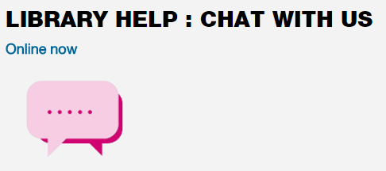For help with searching, printing, downloading, making notes and other features of the packages, use the Help links in any ebook package. (The number of pages of any ebook you can download or print may be restricted; attempts to override this, or to log in multiple times and download/print different sections, may result in access to the package being locked altogether.)
For more help with ebooks, use the Library’s Live Help service (on the Library home page…)

or contact the Education Librarians by phone (01865 488220), email (educationlibrarians@brookes.ac.uk) or in person at Harcourt Hill Library.

