Finding journal articles

Use this worksheet to help you plan & carry out an effective database search

Step 1: Define your topic

Write your search question below. Don’t choose a topic that is too broad or too narrow.

Step 2: Choose your keywords

Look at your question - what are the keywords, ie the main ideas? Write your keywords below:

Step 3: Identify alternative keywords

Remember, databases only look for the exact words you put into the search.

Remember that databases only look for the exact words you actually put in, and different authors may have described your topic in different ways. For each of your keywords from Section 2, add alternative words below that describe each one.

Think about synonyms (ie words that mean the same thing), American spellings if you want those, acronyms (like KS for Key Stage) and alternative spellings.
Remember: Truncation (usually *) will find alternative word endings eg educ* will find education, educating etc. Wildcard (usually ?) in the middle of a word will find alternative spellings eg behavio?r will find behavior and behaviour.
Different authors may describe the same topic in different words.
For each of your keywords from Step 2, write down below some alternative words to describe that idea.
Think about synonyms, abbreviations (eg KS1 for Key Stage 1) and US/UK spellings eg behavio(u)r.

Step 4: Choose your databases

Go to the Library’s Course Resource Help page for Education (or Early Childhood) from the Library home page. Open up the Databases section (under Resources).
Read the descriptions and decide which is the best database for you to search.

You can use the one-stop search link at the top if you want to search all the Education databases in one go – bear in mind that if you do this, you will be including the American database ERIC, so you will get a lot of US results which you may need to filter out.

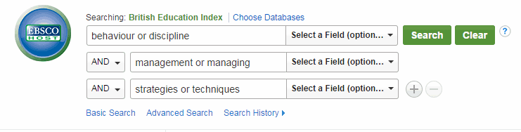
Step 5: Put your groups of alternative keywords into the search boxes like this:

- One idea per search box
- All alternative words for that idea in that box, linked with or
- The database automatically puts AND between the boxes (groups of keywords) for you.
- Then hit Search !

Step 6: Evaluate your search results

- How many results have you got? Are they (judging by the titles/abstracts of the first few) what you want?

- If you have too few results, perhaps your search topic is too specific – or you need more alternative keywords for each idea.

- If you have too many results, perhaps your search topic is too broad. If not, you can limit your search by Date, to Full Text articles only, and to articles from only peer reviewed (academic) journals. (Limit menu on the left.)

Step 7: Choose the articles you want and print, save or email them
Once you have followed all these steps you are now ready to go and try out your search.

For more advice or help, please contact Hazel Rothera or Ruth Dryden, your Education Librarians: mailto:educationlibrarians@brookes.ac.uk Tel: 01865 488220

With thanks to Deborah Lepley, Pauline Hockley and Katherine Staples for their help in the creation of this sheet.

- Print, save or email individual articles using the buttons on each article
- Or add a selection of articles to the Folder & then print/save/email them all at once
- Or Export them directly to EndNote Web, our referencing software (http://bit.ly/BrookesLibraryEndNote)

For more advice or help, please contact Hazel Rothera or Charlotte Olehnovics, your Education Librarians: educationlibrarians@brookes.ac.uk or watch our video: https://bit.ly/educsearch21

