Finding journal articles

Use this worksheet to help you plan & carry out an effective database search

Step 1: Define your topic

Write your search question below:

Remember not to choose a topic that is too broad or one that is too narrow.

Step 2: Choose your keywords

Look at your search question – what are the keywords, ie the main ideas?
Write your keywords below:

Step 3: Identify alternative keywords

Remember that databases only look for the exact words you actually put in, and different authors may have described your topic in different ways. For each of your keywords from Step 2, add alternative words below that describe each one.

Think about synonyms, abbreviations (like KS for Key Stage) and alternative spellings.
Remember: Truncation (usually *) will find alternative word endings eg educ* will find education, educating etc. Wildcard (usually ?) in the middle of a word will find alternative spellings eg behavio?r will find behavior and behaviour.

Remember that databases only look for the exact words you actually put in, and different authors may have described your topic in different ways. For each of your keywords from Section 2, add alternative words below that describe each one.

Think about synonyms (ie words that mean the same thing), American spellings if you want those, acronyms (like KS for Key Stage) and alternative spellings.
Remember: Truncation (usually *) will find alternative word endings eg educ* will find education, educating etc. Wildcard (usually ?) in the middle of a word will find alternative spellings eg behavio?r will find behavior and behaviour.

Step 4: Choose your databases

Go to the Library’s Subject Help page for Education (or Early Childhood) from the Library home page. Open up the Databases section.

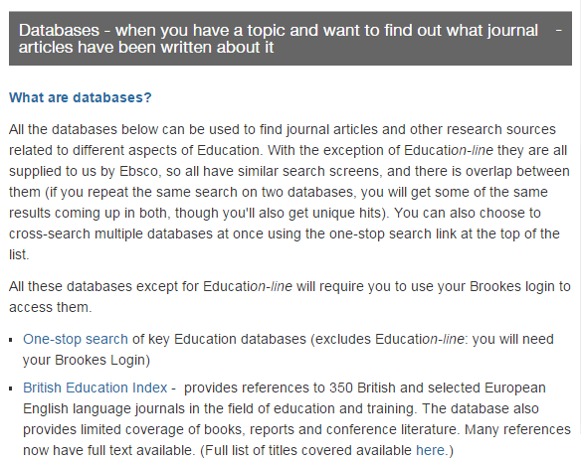
Read the descriptions and decide which is the best database for you to search.

You can use the one-stop search link at the top if you want to search all the Education databases in one go – bear in mind that if you do this, you will be including the American database ERIC, so you will get a lot of US results which you may need to filter out.

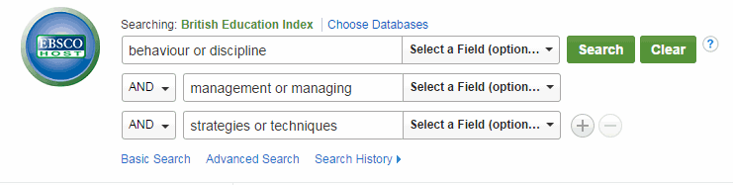

Step 5: Put your groups of alternative keywords into the search boxes like this:

Use each search box for one idea, and put in all your alternative words for that idea, with or between them like this. You’ll notice that the database automatically puts AND between the boxes (groups of keywords) for you. Then hit Search !

Step 6: Evaluate your search results

How many results have you got? Are they (judging by the titles/abstracts of the first few) what you want?

If you have too few results, perhaps your search topic is too specific – or you need more alternative keywords for each idea.

If you have too many results, perhaps your search topic is too broad. If not, you can limit your search by Date, to Full Text articles only, and to articles from only peer reviewed (academic) journals. (The Limit menu is to the left of your search results.)

Step 7: Choose the articles you want and print, save or email them
Once you have followed all these steps you are now ready to go and try out your search.

For more advice or help, please contact Hazel Rothera or Ruth Dryden, your Education Librarians: mailto:educationlibrarians@brookes.ac.uk Tel: 01865 488220

With thanks to Deborah Lepley, Pauline Hockley and Katherine Staples for their help in the creation of this sheet.

You can either go into each article you want and print, save or email it directly to yourself, or you can add a selection of articles to the Folder (use the blue Add to Folder button) then go in to the Folder (in the top menu) and from there print/save/email your list of articles.

For more advice or help, please contact Hazel Rothera or Charlotte Olehnovics, your Education Librarians: educationlibrarians@brookes.ac.uk Tel: 01865 488220 or watch our video: http://bit.ly/educdbasesvid

