Introduction to PPRs
1 day Overview workshop
Presentation

Page text

Introduction to PPRs
1 day overview workshop presentation

This section contains the link to your Participative Process Review Presentation
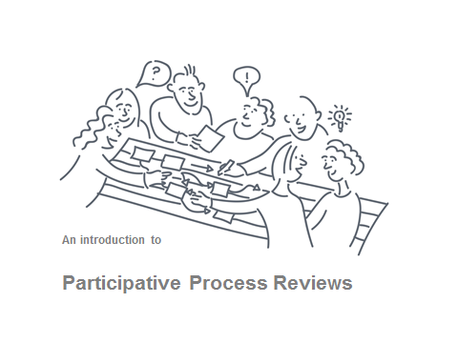
Link to PPR 1 day Workshop Powerpoint Presentation
(Condensed version for Review Study Leaders PPR mapping)

Note: This workshop adopts a simple approach to process mapping whilst acknowledging that a whole plethora of advice is available to satisfy people who would like to progress to greater complexity.

Key features
- slides are template free to enable adoption to own organisation template
- animations function (is enabled) for gradual reveal of slide information
- incorporating notes pages with synopsis information and facilitator observations (please note these are not intended to be full tutor notes)
- workshop timings and refreshment breaks are deliberately omitted reflecting the agile approach to workshop delivery. Facilitator will need to use their intuition with regard to workshop content flow
- a condensed version is available for Process Study Review Leaders to subsequently conduct a process mapping review workshop

Pre workshop
Good practice to send pre workshop information out to delegates 2 weeks in advance
- prep workshop information is contained in delegate handouts section
- your Process Review Draft Terms of Reference
- link to the SUMS Participative Process Change good practice guide (pdf)

Workshop set up requirements
- Room requirements: A large room equipped with a PC, projector, sound, internet connection, flipchart stand and paper, optional whiteboard
- Room layout: Key requirement is formation of one long table minimum 1 meter in width to enable rollout of plotting paper. Ideally space to move around table for discussions

For the workshop
- Presentation
- Workshop handouts including a copy of the draft terms of reference
- Flip chart paper and pens

For process mapping activities
- Roll of paper: we recommend 36” (914 mm) CAD plotting paper rolls average price £22 per roll: alternatively double strength lining paper is usually smaller at 540mm and cheaper
- 1 meter long ruler (or long straightedge) to draw up swim lanes
- Post it notes (various colours) 76mm by 127 mm and 76mm by 76mm
- Scissors
- Blue tack

We also suggest that the Process Study Review leader bring a camera device with them to record images of output materials in case originals become unstuck post workshop transit

Design and Prep Notes

