Participative Process Reviews
Session 0 | Process mapping software applications | Ver: 09 Jan 2017

Lucidchart

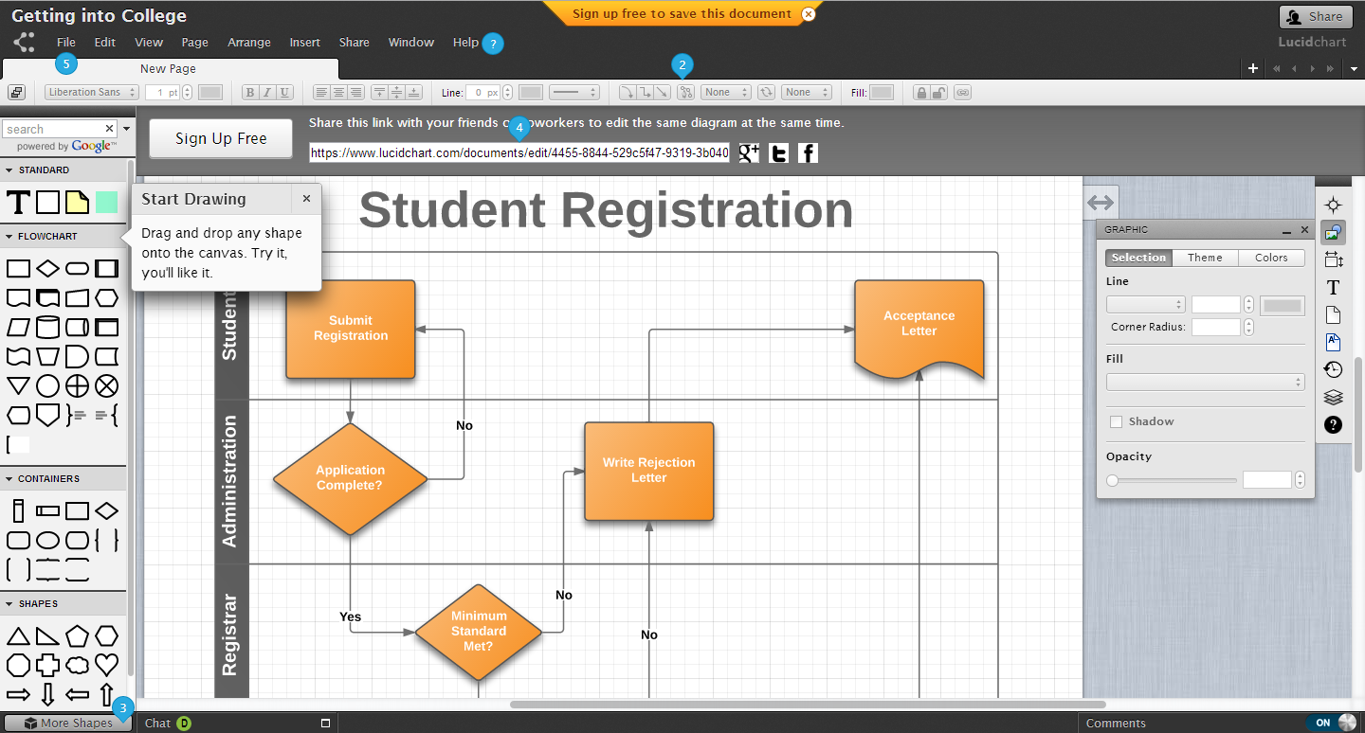

Lucidchart is an easy to use flowchart software being widely endorsed by users around the world.

For quick overview summary
- go to www.lucidchart.com/ and video //youtu.be/sHk0CzKaS6Y
- how it integrates with Google drive www.youtube.com/watch?v=aRB_UfNmrrU

Lucidchart for education

Staff at Universities can apply to Lucidchart for an educator or faculty account
https://www.lucidchart.com/pages/usecase/education

If you already use Google drive select the button and go to connect more apps: In the search Apps box type:- Lucidchart for education
New

Microsoft Visio

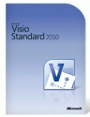 | 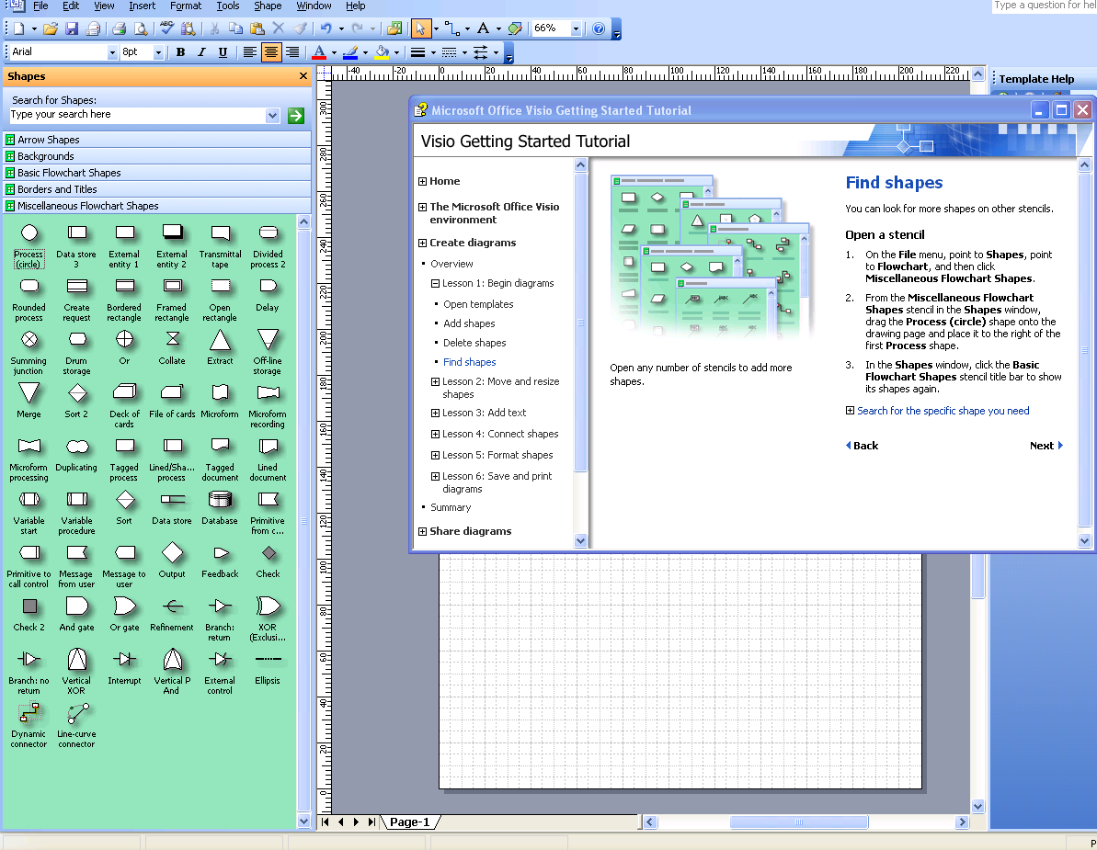
Obtaining a user licence for VISIO
Most Universities have special licensing arrangements for Microsoft products.
Please liaise with your IT department or equivalent.

