Participative Process Reviews
Session 3 | Gathering process information | Ver: 08 Jul 2015

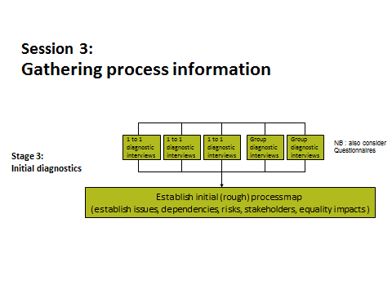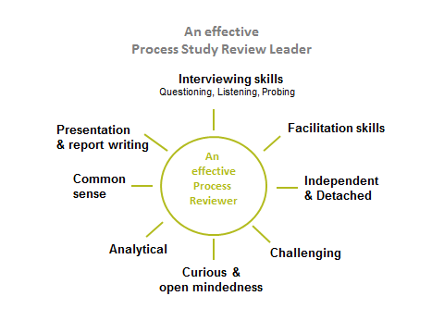

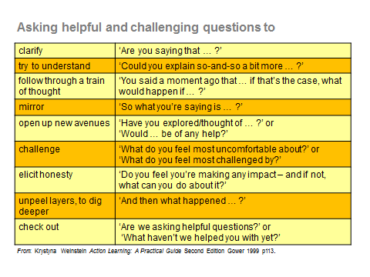

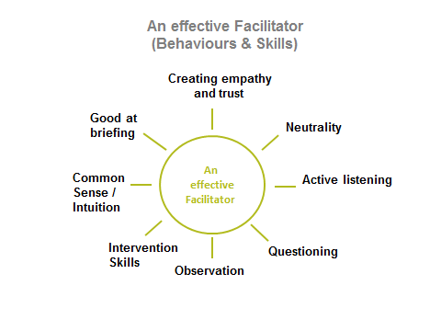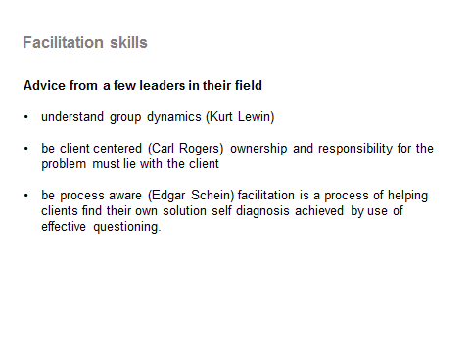

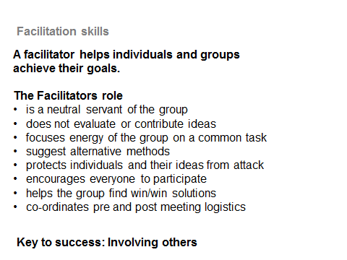

Facilitators check list

- start out and agree ground rules with the group
- keep proceedings moving; sustain momentum, give a kick group a kick start where necessary
- give information if absolutely necessary, but try not to be too directive; resist the temptation to be a leader rather than a facilitator.
- encourage participation
- ask questions to draw them out on issues
- ensure fair play i.e. don’t let some people dominate the proceedings by talking over others
- handle conflict when it arises (don’t ignore it)
- set accepted levels of behaviour
- manage the time
- keep the group on track. Don’t allow them to go off at spurious tangents (or know when to direct them back to the task in hand)
- moderate where there are disagreements, but remain neutral; don’t be drawn into evaluation
- remind them at opportune times that they are required to present their findings (where appropriate)

and finally

- don’t own the discussion/outcomes; its theirs not yours

Ground Rules

Most groups will be able to put together a set of ground rules relevant to the situation in hand.

Here is an example

- All focus on one conversation. One person speaks at a time, side conversations are taken away from the group.
- Fairness: No one will be called on twice on a particular topic until all those who want to have spoken once.
- Be constructive. Create a positive context and supportive framework. Acknowledge the past fully, yet focus on the future.
- Test assumptions and inferences. Ask for more information.
- Be specific. Use examples if needed so people know what you're talking about.
- Take responsibility for your own feelings and experiences. Use “I” statements (for example,
- Keep it real, keep it relevant. Be honest. Be direct, yet kind.
- Bring un-discussable issues into the open.

