Participative Process Reviews
Session 4 | Introduction to process mapping | Ver: 05 Dec 14

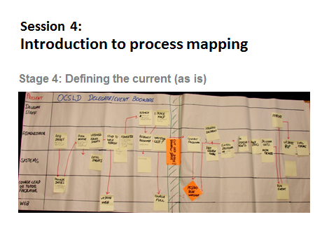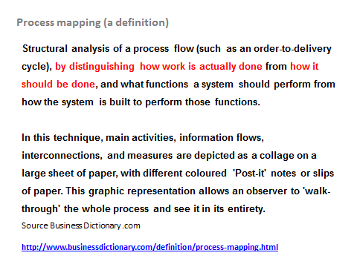

Definition and application of process mapping

- A process map is a visual tool to help analyse, communicate, discuss and document business processes. It illustrates the sequence of actions and information.
- The level of detail in a process map can be very high. It is important to map all tasks that are being carried out in one place at one time by one person or system.
- Process maps are used to identify how current processes are being performed and how well these are being performed.
- Similarly, process maps are used to identify and elaborate opportunities for improvement.
- Process maps help to standardise processes within an organisation.

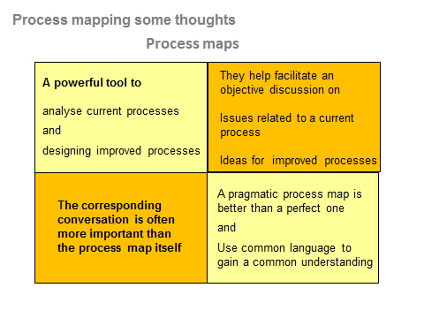

Drawing the process map

- Inputs and outputs should be identified first. A clear definition of key inputs and outputs must be provided.
- Start and End points as well as customers should be clear.
- Start with a high-level Flow Diagram and then drop to the next level of detail if necessary. Use sub-processes.
- Walk through each key sub-process step by step. Stay focussed here.
- The level of detail should be adequate to describe located inefficiencies.
- Identify process and technology opportunities for improvement as you go to the end of each sub-process.
- A person not familiar with the process should be able to understand the flow easily without any further explanation.

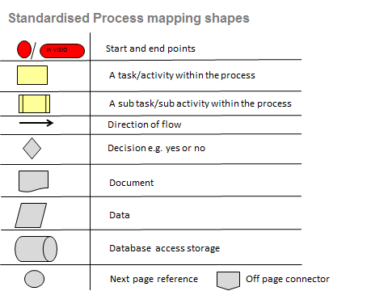

The DO’s and DON’T’s of Process Mapping

DO’s
- DO map the process as it actually happens.
- DO talk to the other people who are involved in the process.
- DO define the beginning and end of the process before you start.
- DO the process map at a high level. Keep it simple and illustrative.
- DO work in a team. Seek advice.

DON’T’s
- DON’T map the process as you think it happens or as you think it ought to happen. Do not interpret.
- DON’T restrict your process map to activities relating to the department that primarily runs the process.
- DON’T attempt to start process mapping before having identified the process’ beginning and end.
- DON’T get bogged down with too much detail.
- DON’T struggle on your own.

Example of process map (Courtesy of SUMS Consulting)

Above is a process map capturing a sequential execution of tasks involving multiple departments depicted in what in what are termed swim lanes.

Swim lane diagrams show what is done by whom and in what sequence.

A swim lane could be allotted to specific information systems which is very useful when the review centres on introducing new IT systems.

Make sure that the process map has a decent layout and doesn’t look messy:
Example of CRM processes (general)

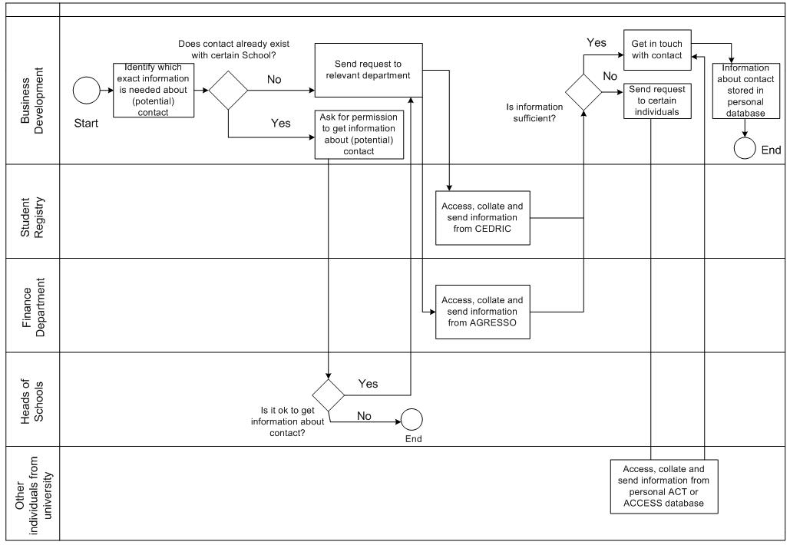
Example of process map (Courtesy of SUMS Consulting)

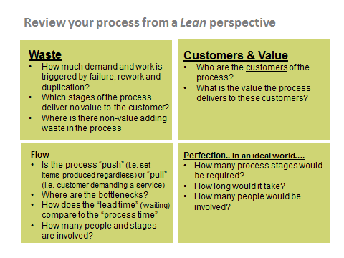

Lean thinking in its broadest sense is a holistic and sustainable approach to do more with less. Lean represents a culture in which organisations continually look to eliminate wastefulness in delivering value to a customer. Key requirements in creating a Lean environment are
- Maintaining an unrelenting focus on providing customer value
- Delivering what is needed by the customer at the right time
- Keeping things moving (flow)
- Apply various techniques to examine and eliminate root causes of waste
- Continuous learning and making everyday improvements
- Taking a long term view (Lean is a journey not a destination)
- Building long term relationships with all stakeholders
- Respecting people
For Lean to succeed the last point is arguably the most important. In Lean its people who create value. They are more important than tools, equipment or capital. Its people who implement processes and utilise equipment. Rooting out waste through Lean depends on creating the right culture and environment where people are respected.
Lean thinking originated in the manufacturing sector (synonymous with Toyota) and has subsequently spread to other sectors.

The Leadership Foundation for Higher Education has a useful development tool kit dedicated to Lean management which is available to members
http://www.lfhe.ac.uk/en/research-resources/publications/lf-mdrs.cfm

