Participative Process Reviews
Session 5 | Design proposal for a new process | Ver: 08 Jul 2015

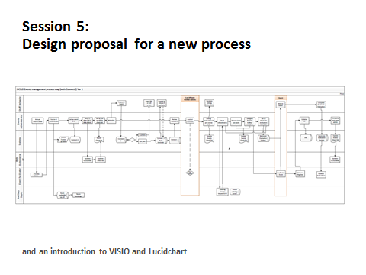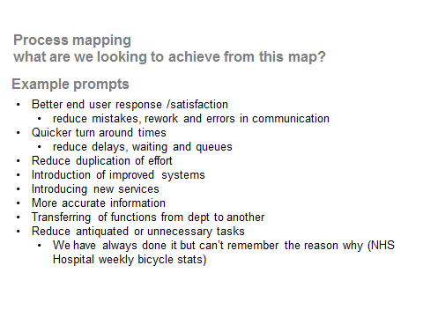

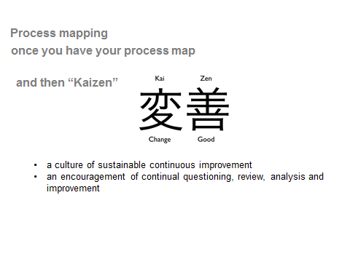

Post workshop
Following on from your workshop day, assign a member of the team to transform your paper and post-it version onto a process mapping software application.

Two applications which are widely used are Lucidchart and Microsoft Visio

Lucidchart 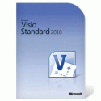

Lucidchart

Lucidchart | 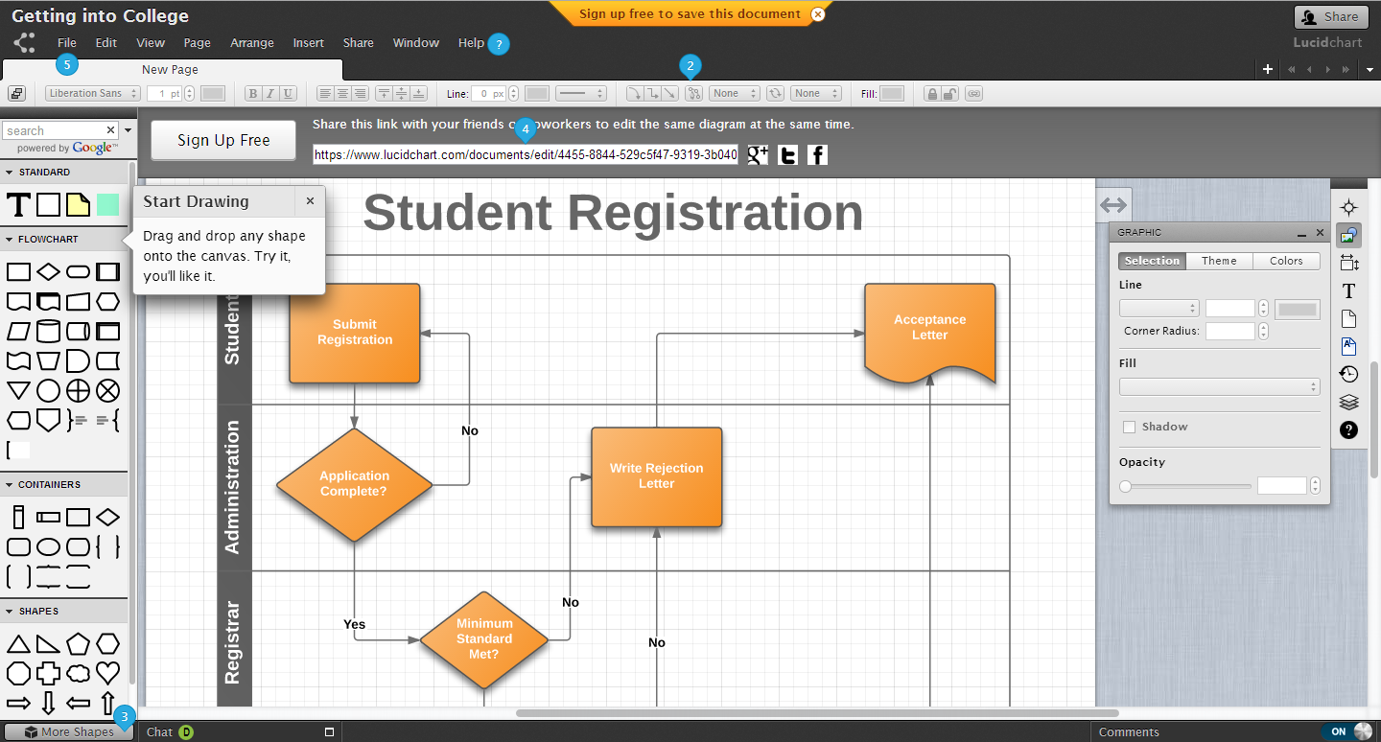

Lucidchart provides the easy to use flowchart software to help you communicate visually.

For quick overview summary go to https://www.youtube.com/watch?v=aRB_UfNmrrU
For further information on Lucidchart go to https://www.lucidchart.com/

It is designed to work efficiently with google docs (also available on ipads)
If using Google drive select the create button and go to connect more apps

 |  |  |  | Connect more apps | In the search Apps box type  Lucidchart

Lucidchart provide free accounts for single users

Once you are signed up for your free limited account you may wish to "get the free educational upgrade" by going to the account settings and selecting the upgrade button.

For even more functionality you can apply to Lucidchart for an educator or faculty account
http://support.lucidchart.com/entries/21648284-Request-an-Educator-or-Faculty-account

Lucidchart says “We love working with educators and faculty members, since we see Lucidchart as the perfect solution to diagramming needs in the classroom.”

Microsoft Visio

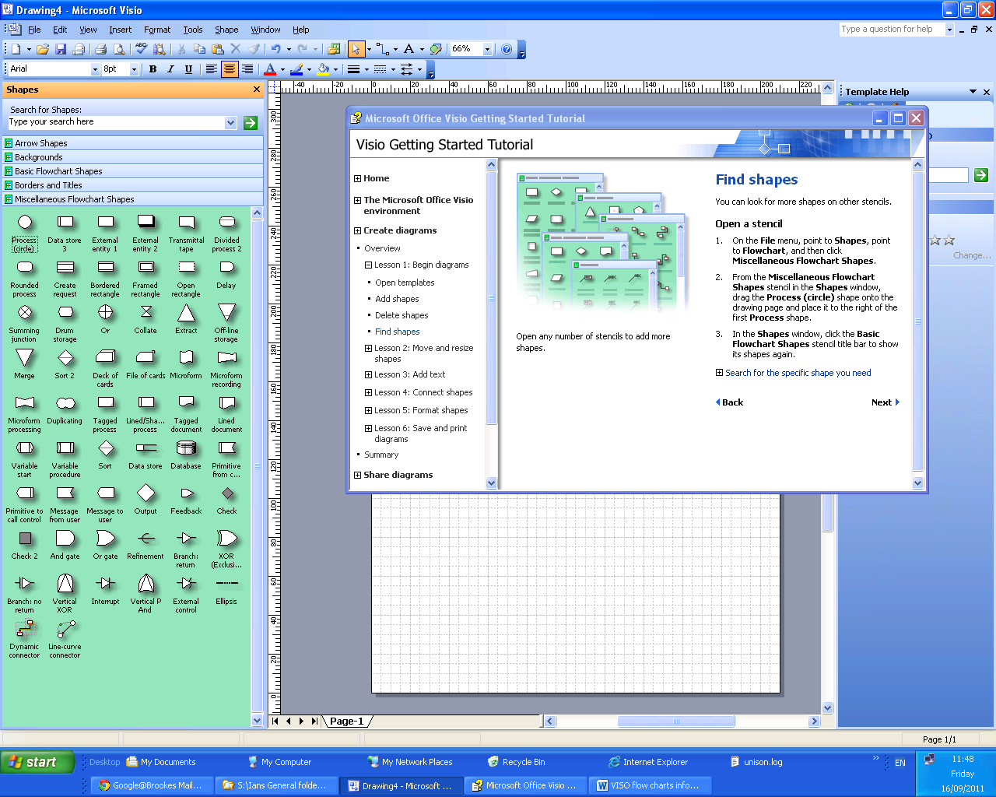

Obtaining a user licence for VISIO
Most Universities have special licensing arrangements for Microsoft products.
Please liaise with your ICT department or equivalent.

