Harcourt Hill Library

Welcome to Harcourt Hill Library, supporting Education, Early Childhood, Philosophy, English Language, and Communication Media & Culture. Staff are happy to help you!

Contact details
Harcourt Hill Library, Harcourt Hill Campus, Oxford, OX2 9AT
General enquiries: Tel: 01865 488222
Education and Early Childhood Tel: 01865 488220 Email: educationlibrarians@brookes.ac.uk
All other Harcourt Hill subjects Tel: 01865 488228 Email: jakers@brookes.ac.uk

Library opening times
Semester: Monday – Thursday 08.30 - 21.00, Friday 08.30 - 18.00, weekends 12.00 - 18.00
PGCE Term: As above except Monday-Thursday 08.30 – 19.00
Vacation: Monday – Friday 09.00 - 17.00 (closed weekends)
Our webpage: www.brookes.ac.uk/library/site-libraries/harcourt-hill-library
Take a virtual tour: bit.ly/hhlibvtour

The Library Help Zone
- Get help with finding books, using the self-service machines, IT, or any Library service
- Get help with locating and using information for your course
- Borrow Chromebooks (small netbook computers which run Web browsers and Google Docs only)
- Get help paying fines on overdue reserved (held) books or lost books
- Get a replacement password if you have forgotten yours
- Borrow headphones

Other facilities
- Borrow, return and renew books on our self-service machines in the foyer
- Collect holds (reserved books) from the shelves near the self-service machines
- Work in peace and quiet: silent study in the Main Reading Room on the ground floor
- Work in a group: in the School Experience Centre (SEC) downstairs. There are also two bookable group rooms in the SEC with a PC, interactive whiteboard and AV equipment
- Computers: 18 PCs available in the Library Training Room when no training sessions are going on. More PCs available in the School Experience Centre and the Main Reading Room.
- Printing, photocopying and scanning: from the Brookes Print Anywhere MFDs, in colour or black-and-white, either from a Brookes PC or from your own device (laptop, tablet or phone). Charge up your Print Anywhere account online
- Plug in your laptop: charging sockets at most study desks
- Wireless: eduroam is available in the Library (register first on the IT Services Web pages)
- Careers Area: for tips and information on jobs and careers, in the Main Reading Room
- TVs, video and DVD players and audio equipment: in the School Experience Centre

Ground Floor

Main Library (textbooks, journals, dictionaries/encyclopedias, silent study area, Careers Area, PCs); Training Room; Helpdesk; printer/copier/scanners

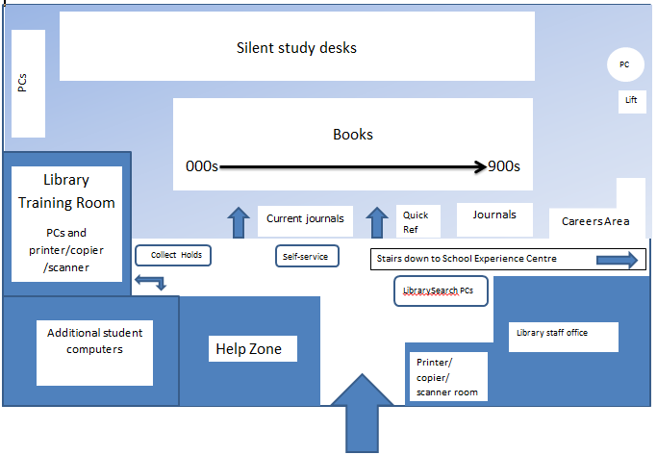

Lower Ground Floor/School Experience Centre

Children’s books and classroom resources; group study rooms and groupwork tables for all students; computers and printer/copier/scanner

