Finding anthropology journals and journal articles

Journals are extremely important sources of scholarly writing; they contain the latest research, scholarship and thinking within a subject area. As they are published frequently (e.g. monthly or quarterly) they are usually much more up to date than books.

Articles in journals tend to focus on specific aspects of a subject in much more detail and often cover topics that will not be written about elsewhere.

Journal article references
When you find a reference to a journal article, it will look something like this:

Gottlieb, A. (1995) ‘Beyond the Lonely Anthropologist’, American anthropologist, 97(1), pp. 21-26.

This is what each element of the reference means:

Gottlieb, A. | the author of the journal article
(1995) | the year of the journal article was published
‘Beyond the Lonely Anthropologist’ | the title of the journal article
American anthropologist | the title of the journal in which the article appears
97(1) | the volume and part number
pp. 21-26 | the page numbers

Finding journal articles - following up references to specific articles
From the Library web pages select the LibrarySearch tab.
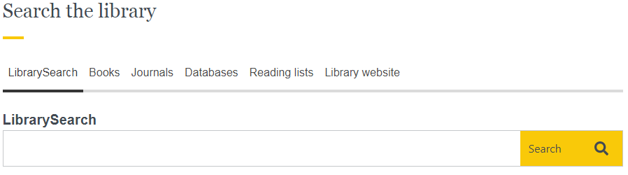

In the search box type in the details of the article (the title, plus the author’s surname).

Click on view full text to see an electronic version of the article. The print holdings of the journal are shown below the green button (if available) should you prefer to photocopy the article.

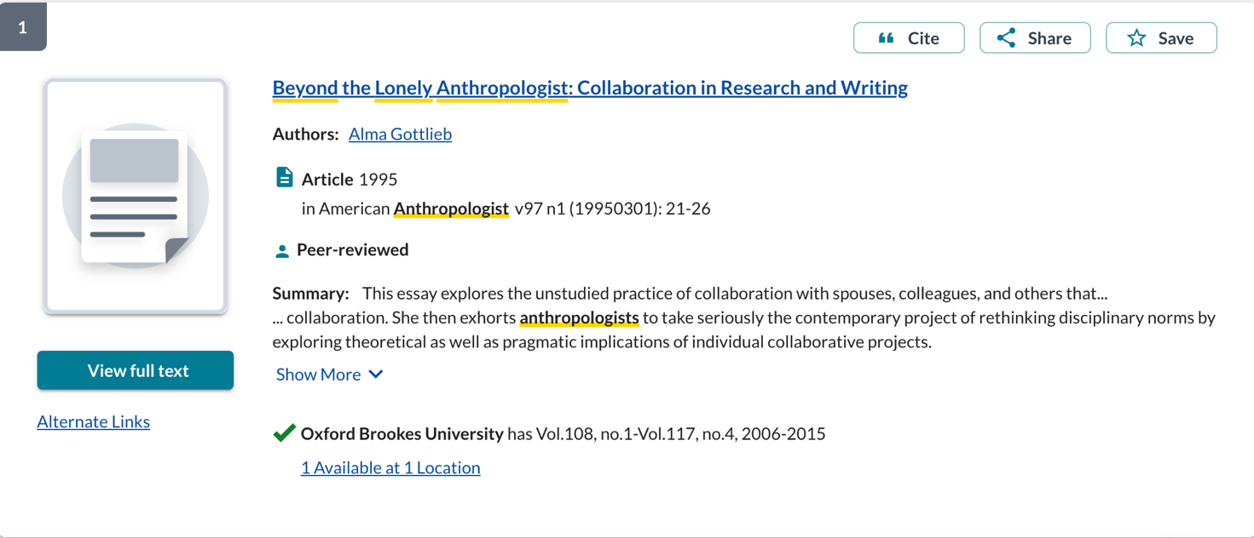

Accessing e-journals
Please try to use links from the Library’s web pages to access our e-resources, as these links may contain additional information which makes accessing that content a much simpler process. Most of the Library’s databases and e-journals will simply prompt you to log in with your Brookes ID and password and once you have logged in you will be able to move to other databases or e-journals without the requirement to log in again during your session.

How do I find out what journal articles have been written on my subject?
To find articles on a particular topic or within a certain journal, you can use LibrarySearch or one of the Library’s wide range of online databases. You can get access to these databases from the library anthropology web pages.

You can search by keywords or subject headings to find references to publications on your topic. Some databases give you direct access to e-journal articles. Other databases will provide you with a list of references to then follow up separately.

Which database should I use?
Anthropological Index – this specialist anthropology Index lists references to journal articles in all branches of anthropology. It is possible to search for journal articles on specific places and ethnic groups.

IBSS (International Bibliography of the Social Sciences) - covers all aspects of anthropology. It includes references to books and links to online journal articles.

JSTOR - an archive of full-text articles from a wide range of academic journals including anthropology. JSTOR does not give access to issues which are less than 3-5 years old but is useful for older journal articles.

Web of Science – a multidisciplinary database that is particularly useful for biological anthropology. It includes links to online journal articles.

How do I obtain articles from journals not available from the Library?
Copies of journal articles not available in print or online from the Library can be requested via the Interlibrary loan service.

More information
There is lots of guidance available on the library anthropology web pages or you can contact your Anthropology Librarian, Ashley Cushman at acushman@brookes.ac.uk.

1 September 2022

