Getting Your Poster Started in Power Point

- Open A1 Academic Poster template.

- Add your title and subheadings (use the pro-forma or copy and paste from a document).
Change font colour/ size – home menu.
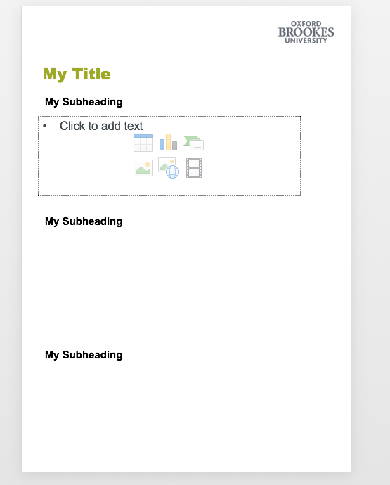
- Change background colour– design menu (far right) - format background (in drop down menu choose solid fill, choose colour etc).
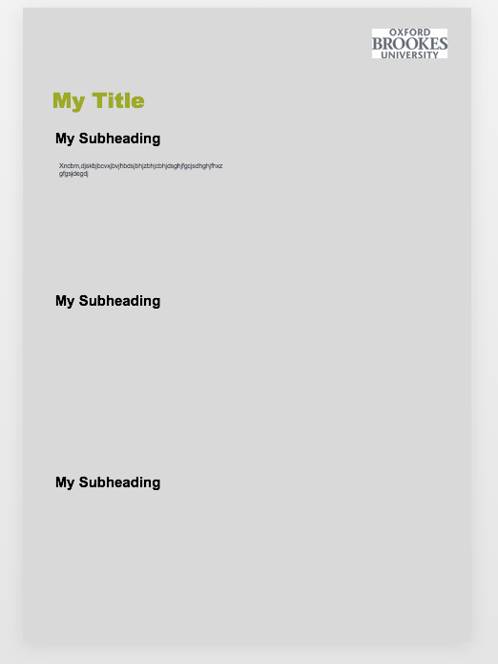

- Add text boxes – Insert - text box,
(or copy and paste multiple text boxes from pro forma).
- Give boxes a colour – Far right of home menu – Shape fill.

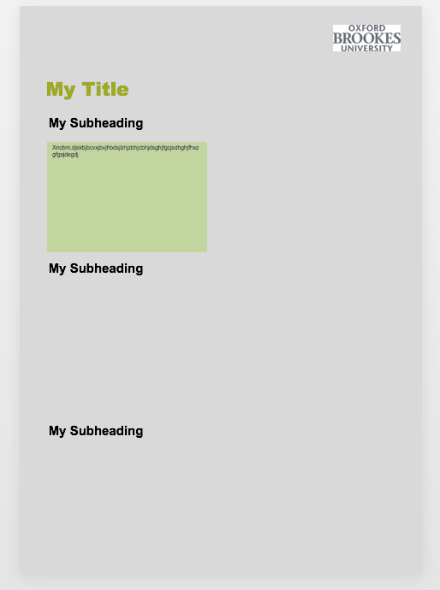

- Add photos – Insert menu - picture symbol. Find images in file or browse and save. Move image to poster and resize (or copy and paste).
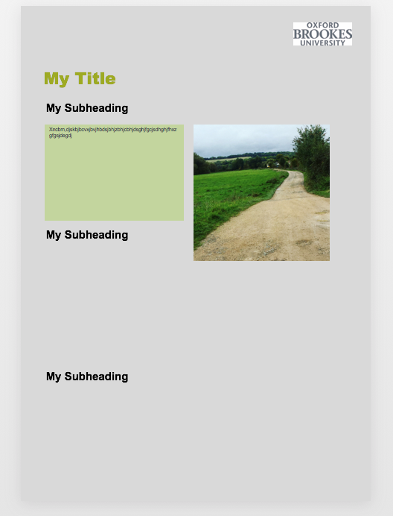

- Add graphs and charts –
- Choose a chart format in PowerPoint – insert menu – chart. Right click on chart to change colours, values etc.
- Import or copy and paste files or charts from Excel or other folders– insert menu - object.

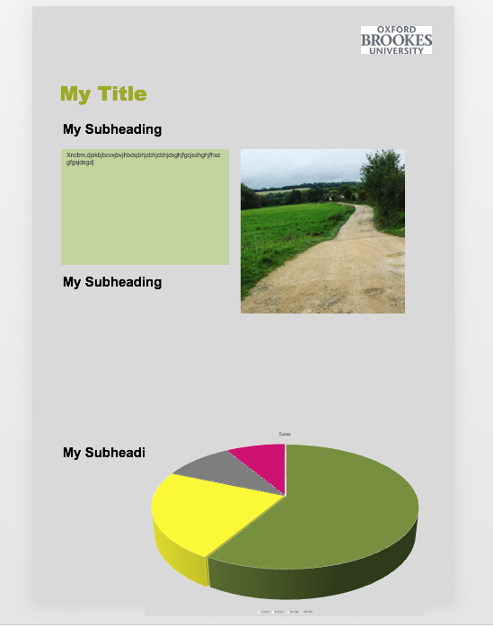

- Once you have all your essential elements move them around, change colours and resize elements to create a balanced layout.

- Save as a power point document.

- For printing – save as a high-resolution PDF.

- Follow instructions on Brookes Print website – Wide Format (A1) Call them if you are unsure.

