Bookmarking an EBSCOhost journal article in Aspire

- Start by going to Aspire (via Reading Lists on the Library home page, or direct to https://brookes.rl.talis.com/index.html ) and signing in as usual with your Brookes staff number and password (see Getting started with Aspire).

- Find the journal article on our Library databases e.g. Academic Search Complete, Business Source Complete, Education Research Complete; or find the journal title via the Journal Titles tab on Library Search, and work your way through to the journal article you want

- Click on the article title to see the abstract and full text option and copy the article Permalink so you can use it in Step 6 below (if a permalink option is not available just use the web address)
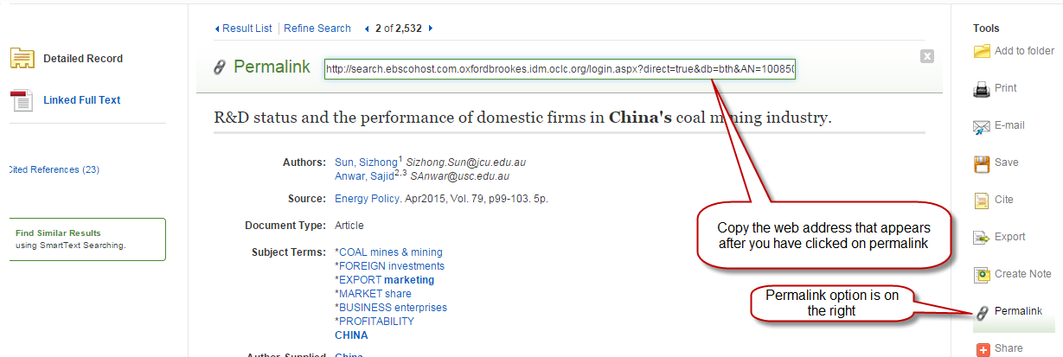
- Now click the blue bookmarking icon on your bookmarks toolbar. (If you don’t have this installed yet, go back to the Getting started with Aspire guide for instructions.)

- The next screen contains the details of the article and a ‘Is part of Journal’ tab.
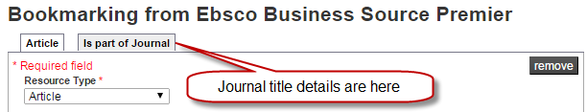
- Add a web address field if not already there, and paste in the permalink or web address so students go via Brookes Login to get full text access:
- Make sure the ‘Online Resource’ box is ticked, and ensure it links to the Web address or permalink you added (not the DOI or the Open URL, as these do not always work)

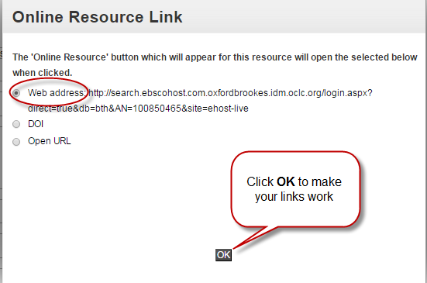

- Finally, click Create.

- When you’ve bookmarked everything you want, go into your list and use ADD RESOURCE to add the items where you want them. Don’t forget to Publish!

