Bookmarking Web pages, online audio/video, and other online materials in Aspire

- Start by going to Aspire (via Reading Lists on the Library home page, or direct to https://brookes.rl.talis.com/index.html) and signing in as usual with your Brookes staff number and password (see Getting started with Aspire).

- On the Web, find the page or document you want. (For online video and audio, see over the page.)

- Many Web pages and PDFs create bookmarks that have almost no information in them (no author, title, date etc). This causes problems for students knowing what the page is and being able to reference it correctly, and for you if you want to generate a Harvard (or other citation style) bibliography from your Aspire list later.

- The solution to this is to add and amend as much of the information as you can, using Add Field in the bookmarking screen (Tip: open the document twice in two separate tabs before bookmarking from one of them, so that you have all the information you need to hand)

- The example below comes from a Government department Web site:

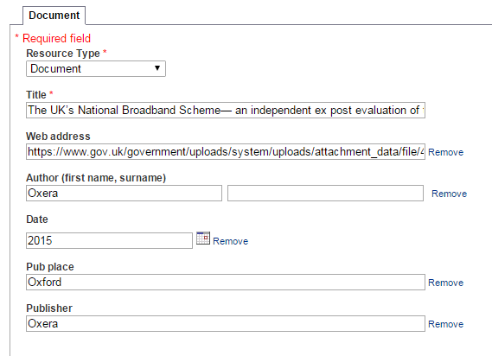

- You now have a much more complete bookmark which will give students better information on your list:

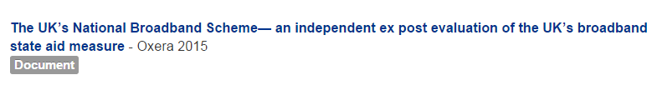

Bookmarking videos and audio from Box of Broadcasts

- If you want students to view a programme (or a clip) from a UK broadcaster, the Library recommends that you do so through our Box of Broadcasts (BoB) service.
- This provides legal, licensed access to UK TV and radio programmes and the links are guaranteed to remain – if you find clips from UK TV programmes on YouTube, they have usually been illegally uploaded and as well as infringing copyright, your links may well break if the broadcaster asks YouTube to take the clip down.
- You can find BoB under “Databases” on the Library homepage (go to B in the alphabetical list).
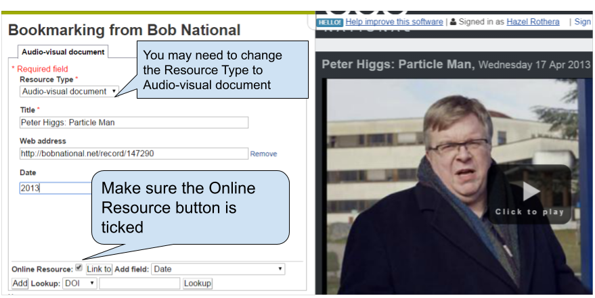
- Once you’ve identified a programme or clip on Box of Broadcasts, or created a playlist, it’s easy to bookmark its link in the usual way in Aspire, and then add a Note for Students about what the clip shows or how long it is.

- Ask your Academic Liaison Librarian if you need more information about using Box of Broadcasts: you can find them at https://www.brookes.ac.uk/library/resources-and-services/course-resource-help
- When you’ve bookmarked everything you want, go into your list and use ADD RESOURCE to add the items where you want them. Don’t forget to Publish!

Bookmarking videos from YouTube

- Check that the YouTube video is legitimate, ie that it was uploaded by its creator and isn’t an illegal copy of a broadcast or commercial video. If you’re unsure, ask your Academic Liaison Librarian.
- Bookmark the video.
- Make sure the Resource Type showing is “Audiovisual Document”.
- Add any fields which are missing for which you have the information, such as Author and Date.
- Click Create.
- When you add the bookmark to lists, in the Note for Students it may be helpful to add extra information about the video’s length and/or content.
- When you’ve bookmarked everything you want, go into your list and use ADD RESOURCE to add the items where you want them. Don’t forget to Publish!

