# Bookmarking book chapters in Aspire

1. Go to Aspire (via Reading Lists on the Library home page, or direct to <https://brookes.rl.talis.com/index.html>) and log in as usual with your Brookes staff number and password (see *Getting started with Aspire*).
2. In a new browser tab, go to [LibrarySearch](https://oxfordbrookes.on.worldcat.org/discovery/) and search for the **book** from which you want to bookmark a chapter. Click on the **book title** to take you into the detail screen for that book. (If you are still in a list of titles, you haven’t gone far enough.)
3. Now click the blue bookmarking icon on your bookmarks toolbar. (If you don’t have this installed yet, go back to the *Getting started with Aspire* guide for instructions.)
4. 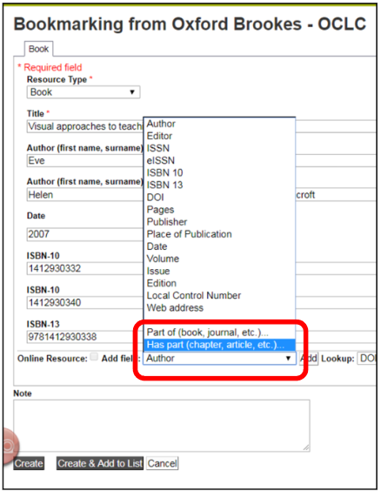Aspire will start by bookmarking the book. Check you’re happy with the book information first. In particular, if it is an edited book and the editors are showing up as Authors, remove them and re-add them as Editors (otherwise any reference generated from the list will be incorrect).
5. To add the chapter information, go to the **Add field** box (towards the bottom of the screen). Pull up the fields menu and select **Has part (chapter, article, etc)**. Click **Add.**
6. A second tab will appear in your bookmark screen. Select **Resource Type** “Chapter”.
7. Change the chapter’s **Title** field to the correct chapter title (or “Chapter 2” etc if the chapters are numbered but not titled).
8. Use **Add field - Pages** to add the page numbers.
9. Use **Add field - Author** to add the chapter author if from an edited 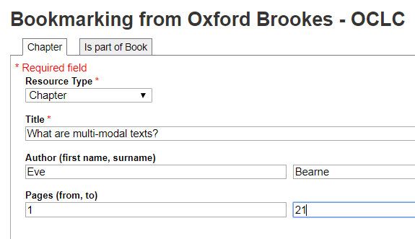book.
10. If the chapter is from an e-book, tick the **Online Resource** box so Aspire will link to the e-book. (If you requested a scan of the chapter from a print book via the Library Scanning Service, add a Web Address field and put in the web address of the scan, then tick the Online Resource box.)
11. Finally, click **Create.**
12. 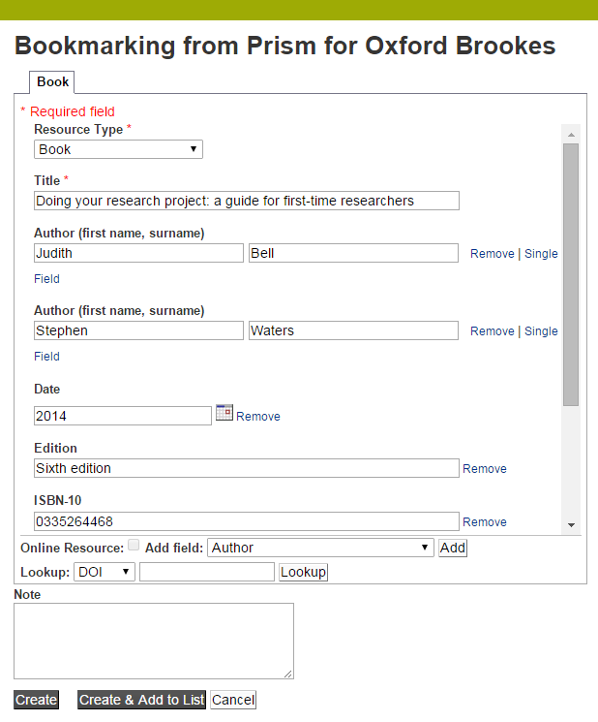When you’ve bookmarked everything you want, go into your list and use ADD RESOURCE to add the items where you want them. Don’t forget to **Publish**!