Bookmarking online journal articles in Aspire

For articles from journals we only have in print, see over the page.

- Go to Aspire (via Reading Lists on the Library home page, or direct to https://brookes.rl.talis.com/index.html ) and sign in as usual with your Brookes staff number and password (see Getting started with Aspire).

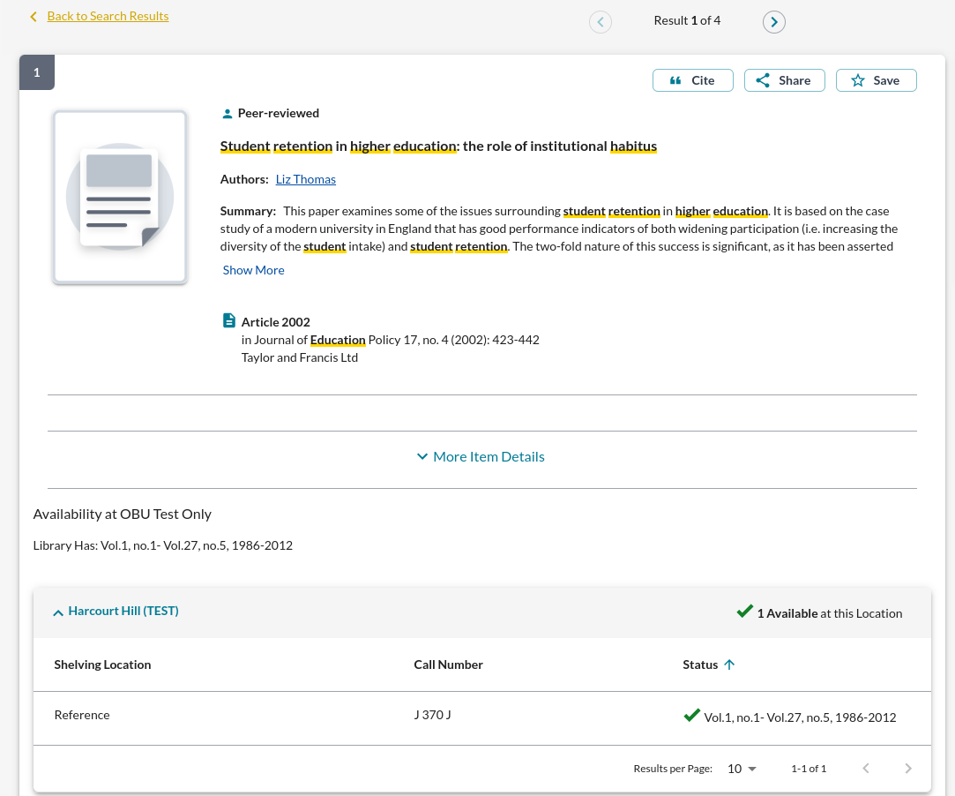
- Find your journal article online (via LibrarySearch, where you can filter your results to Format-Article, or via one of our full-text databases – this may involve you logging in with your Brookes Login)
- If you found your article via LibrarySearch: click on its title (so the article details are displayed on the right) to get the best page to bookmark. Do not click through to a PDF and attempt to bookmark that - it won’t work properly.
- Click the “View full text” button on the record and copy the URL you are given. Now go to step 7.
- If you found your article via another database: for the best results, click through from your search results to a page where only that article’s details are displayed, but not through to a PDF (PDFs do not bookmark well).
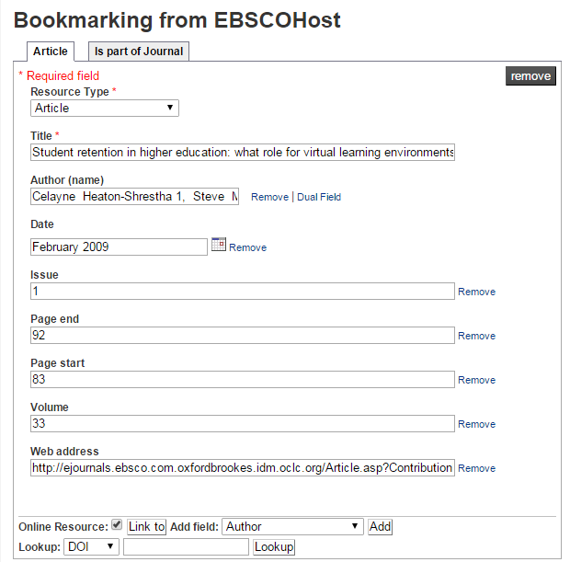
- Copy the full URL (Web address) of this page for Step 9. (For Ebsco articles, copy the Permalink.)
- Click your blue Talis bookmarking icon on your browser toolbar. (If you don’t have this installed yet, go back to the Getting started with Aspire guide for instructions.)
- The bookmarking screen appears, with an Article tab and a Journal tab. Check the information in each field looks right, as some articles bookmark more accurately than others.
- If there isn’t a “Web address” field, add one using the “Add field” button. Paste in the Web address or permalink you copied in Step 4/6.
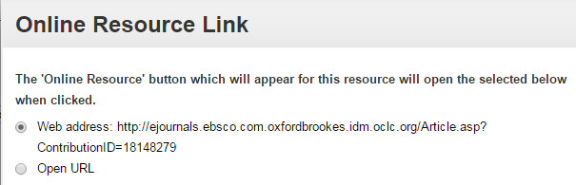
- Make sure the Online Resource button is ticked. This will bring up a dialogue box asking where you want the Online Resource Link to go to. Make sure the “Web address” option is ticked, as Open URL or DOI links do not always work especially off-campus.

- Click Create.
- When you’ve bookmarked everything you want, go into your list and use ADD RESOURCE to add the items where you want them. Don’t forget to Publish!

Bookmarking print-only journal articles

If we only have a particular journal article available in print, you can still bookmark the print journal and then add article details manually, so your students know where to find it.
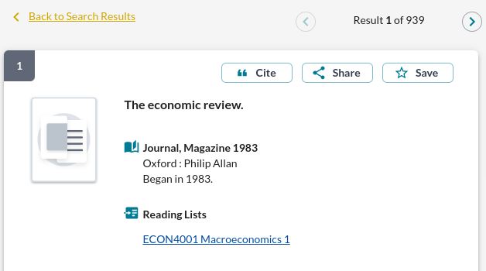

- Find the print journal title via the Journal Titles tab on LibrarySearch.

- Click on the journal title to go to the title details screen.

- Now click the blue bookmarking icon on your bookmarks toolbar. (If you don’t have this installed yet, go back to the Getting started with Aspire guide for instructions.)

- A bookmarking screen comes up with the basic journal details.

- In the “Add field” box, pull up the menu and select “Has part (chapter, article, etc)”. Click Add.

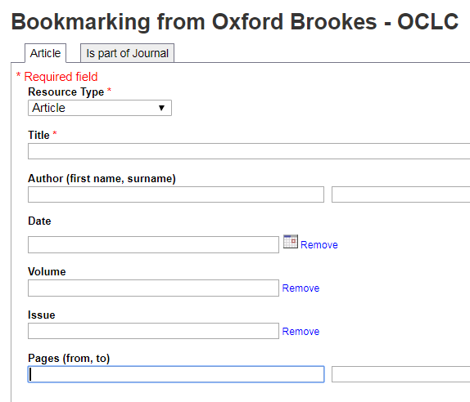

- This brings up a new tab where you change the Resource Type to Article, then manually add the article details. Use the “Add field” menu again to add boxes for Author, Date, Volume, Issue and Pages, and fill in the details. You will also need to edit the article Title field.

- When you are happy, click Create.

- If you’ve added a journal article that the Library only has in print, consider requesting a scan from the Library Scanning Service so that your students can also access the article online (you can add the scan link to your bookmark on your reading list - just add a Web Address field).

- When you’ve bookmarked everything you want, go into your list and use ADD RESOURCE to add the items where you want them. Don’t forget to Publish!

