Bookmarking online journal titles in Aspire

For journal titles we only have in print, see over the page. If you want to bookmark a specific journal article (in print or online) see the separate guides on Bookmarking journal articles in Aspire or Bookmarking an Ebscohost journal article in Aspire.

- Start by going to Aspire (via Reading Lists on the Library home page, or direct to https://brookes.rl.talis.com/index.html) and signing in as usual with your Brookes staff number and password (see Getting started with Aspire).

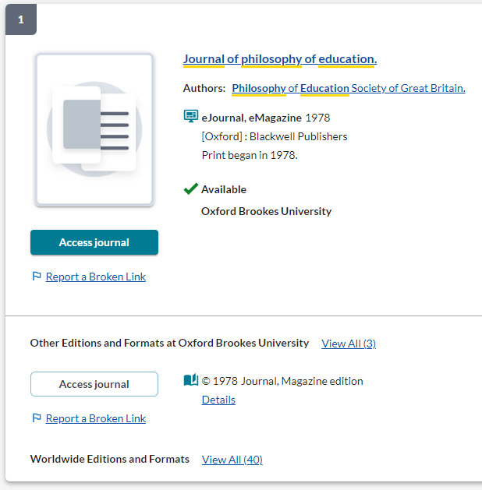
- Go to LibrarySearch on the Library home page, select the Journal titles tab, and enter your journal title.

- Find the journal you want in the search results (make sure it says Available: Oxford Brookes University) and click on its title to get through to the journal details screen.
This is the screen you should bookmark a journal from. (If you are still in a list of titles, you haven’t gone far enough.)
- Now click the blue bookmarking icon on your bookmarks toolbar. (If you don’t have this installed yet, go back to the Getting started with Aspire guide for instructions.)

- The bookmarking screen appears – it should show the journal title, ISSN and Web address.

- Make sure the Online Resource button (at the bottom) is ticked.

- This will bring up a dialogue box asking where you want the Online Resource Link to go to – it will default to Open URL (where LibrarySearch automatically sends users to a link)

- (You can check for the best online access by looking at “Access online” on the LibrarySearch record – you can then click through to the best access, copy the Web address and use “Add Field – Web address” to add this to the bookmark if you want; in that case, change the Online Resource option to your Web address).

- Finally, click Create.

- When you’ve bookmarked everything you want, go into your list and use ADD RESOURCE to add the items where you want them. Don’t forget to Publish!

Bookmarking print-only journal titles in Aspire

If we only have a particular journal available in print, you can still bookmark it so your students know where to find it in the Library (for e-journals, see over the page). If you want to bookmark a specific journal article (in print or online) see the separate guides on Bookmarking journal articles in Aspire or Bookmarking an Ebscohost journal article in Aspire.

- Start by going to Aspire (via Reading Lists on the Library home page, or direct to https://brookes.rl.talis.com/index.html) and signing in as usual with your Brookes staff number and password (see Getting started with Aspire).

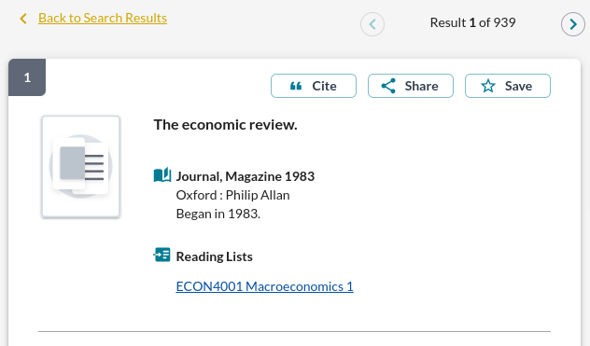
- Go to LibrarySearch on the Library home page, select the Journal titles tab, and enter your journal title.
Bookmark from this page

- Find the journal you want in the search results and click on its title to get through to the journal details screen, showing the journal’s availability in the Library. This is the screen you should bookmark a journal from. (If you are still in a list of titles, you haven’t gone far enough.)

- Now click the blue bookmarking icon on your bookmarks toolbar. (If you don’t have this installed yet, go back to the Getting started with Aspire guide for instructions.)

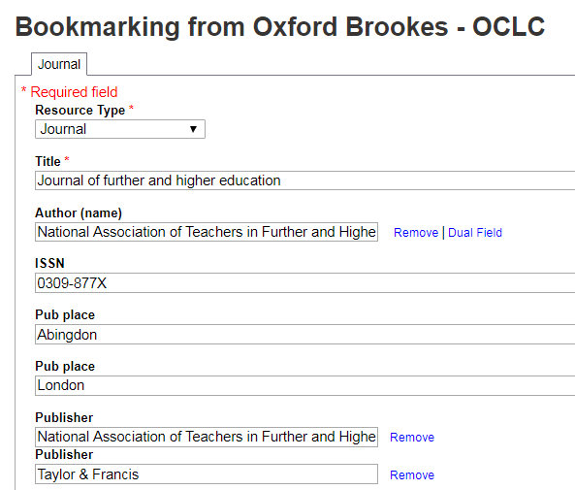

- A bookmarking screen comes up with the journal details.

- When you’ve checked they look correct, click Create. That’s all you need to do!

- When you’ve bookmarked everything you want, go into your list and use ADD RESOURCE to add the items where you want them. Don’t forget to Publish!

