Bookmarking print books and e-books in Aspire

- Go to Aspire (via Reading Lists on the Library home page, or direct to https://brookes.rl.talis.com/index.html ) and sign in as usual with your Brookes staff number and password (see Getting started with Aspire).

- In a new browser tab, go to LibrarySearch and search for the book that you want.

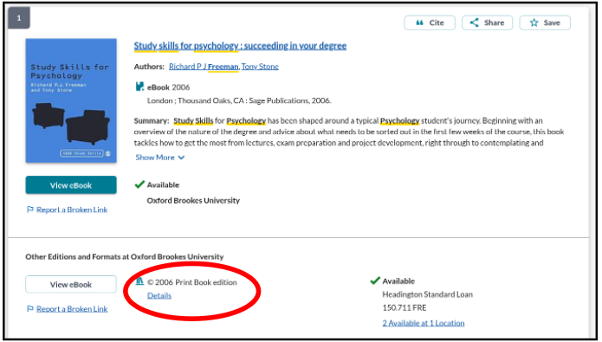
- Many Library books are available both as print and e-books. You can combine both in one bookmark (this shows students availability information for both, while avoiding your list getting very lengthy with duplicate bookmarks).

- Where we have both print and e-books, always bookmark the print book (this will usually link to the print book automatically in LibrarySearch and Aspire - whereas the converse is not the case). If the e-book record comes up first in LibrarySearch, find the print by clicking on the Print book Details link.

- Make sure you have clicked through to the screen which only has the details of your book in the right-hand half (If you are still in a list of titles, you haven’t gone far enough.) If we have both print and e-book availability, you should be able to see both at this point.

- Now click the blue bookmarking icon on your bookmarks toolbar. (If you don’t have this installed yet, go back to the Getting started with Aspire guide for instructions.)

- This opens up the Bookmarking screen, in which all the information about the book should already be correctly loaded.
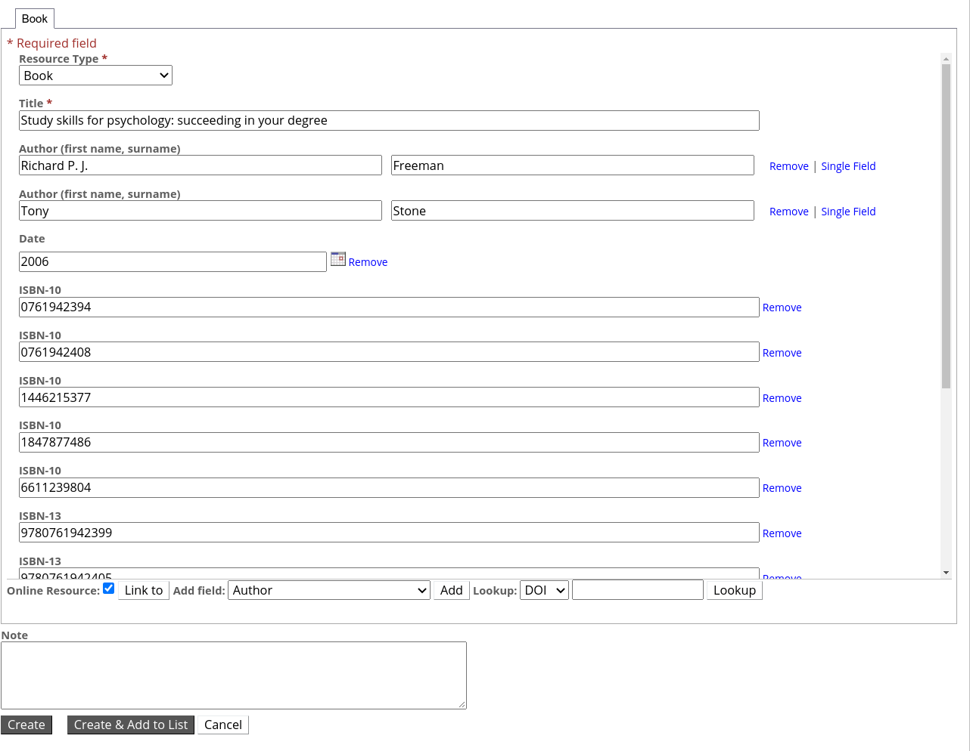

- If (only if!) your book is available from the Library as an e-book, make sure the Online resource box at the bottom of the bookmark is ticked. Confirm the Online Resource option that comes up (“Web address” if that is offered, “Open URL” if not.)
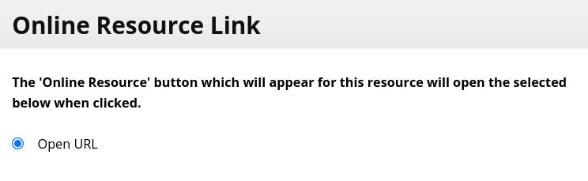

- Finally, click Create.

- When you’ve bookmarked everything you want, go into your list and use ADD RESOURCE to add the items where you want them. Don’t forget to Publish!

