Bookmarking scanned book chapters from the Library scanning service in Aspire

(To bookmark scans of journal articles, see over the page.)

- Start by going to Aspire (via Reading Lists on the Library home page, or direct to https://brookes.rl.talis.com/index.html) and signing in as usual with your Brookes staff number and password (see Getting started with Aspire).
- In a new browser tab, go to LibrarySearch and search for the book from which you want to bookmark a chapter. Click on the book title to take you into the detail screen for that book. (If you are still in a list of titles, you haven’t gone far enough.) NB - if the Library does not hold the book, change LibrarySearch to Worldwide to find it.
- Now click the blue bookmarking icon on your bookmarks toolbar. (If you don’t have this installed yet, go back to the Getting started with Aspire guide for instructions.)
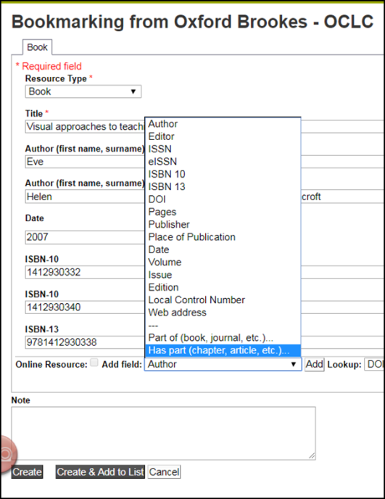
- Aspire will start by bookmarking the book. Check you’re happy with the book information first. In particular, if it is an edited book and the editors are showing up as Authors, remove them and re-add them as Editors (otherwise the Harvard reference will be incorrect).

- To add the chapter information, go to the Add field box (towards the bottom of the screen). Pull up the fields menu and select Has part (chapter, article, etc). Click Add.
- A second tab will appear in your bookmark screen. Select Resource Type “Chapter”.
- Change the chapter’s Title field to the correct chapter title (or “Chapter 2” etc if the chapters are numbered but not titled).
- Use Add field - Pages to add the page numbers.
- Use Add field - Author to add the chapter author if from an edited book.
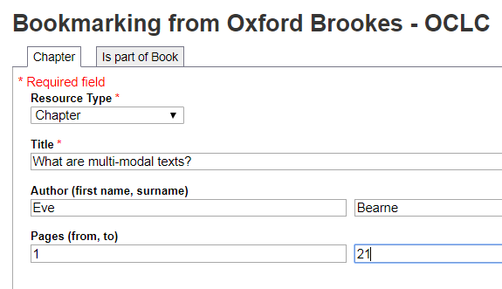
- Use Add field - Web address to add the Web address for your scan which you were given by the Library Scanning Service.
- Tick the Online Resource box, and make sure it is linking to the Web address you just added.
- Finally, click Create.
- When you’ve bookmarked everything you want, go into your list and use ADD RESOURCE to add the items where you want them. Don’t forget to Publish!

Bookmarking scanned journal articles from the Library Scanning Service in Aspire
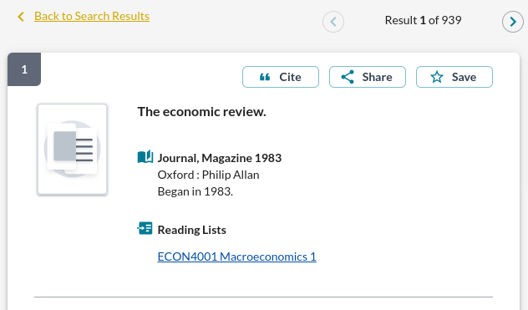
- Find the print journal title via the Journal Titles tab on LibrarySearch. (NB - if the Library does not hold the journal, change LibrarySearch to Worldwide to find it.)

- Click on the journal title to go to the title details screen.

- Now click the blue bookmarking icon on your bookmarks toolbar. (If you don’t have this installed yet, go back to the Getting started with Aspire guide for instructions.)

- A bookmarking screen comes up with the basic journal details.

- In the “Add field” box, pull up the menu and select “Has part (chapter, article, etc)”. Click Add.

- A second tab will appear in your bookmark screen. Select Resource Type “Article”.
- In the Title field, enter the correct article title.
- Use Add field - Author as many times as necessary to add all the article authors.
- Use Add field - Date to add the publication year.
- Use Add field - Volume to add the volume number.
- Use Add field - Issue to add the issue.
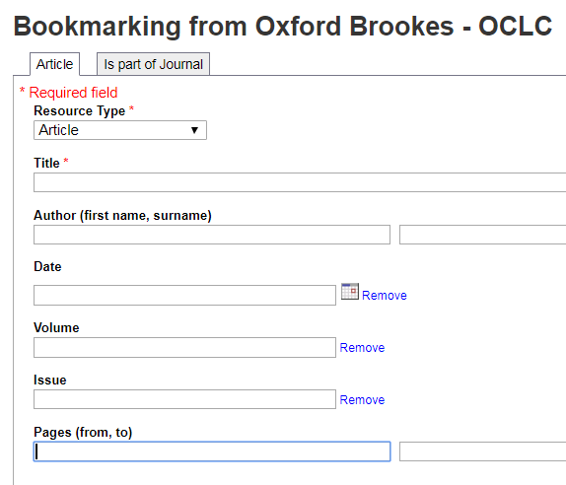
- Use Add field - Pages to add the pages.
- Use Add field - Web address to add the Web address for your scan which you were given by the Library Scanning Service.
- Tick the Online Resource box, and make sure it is linking to the Web address you just added.
- When you are happy, click Create .
- When you’ve bookmarked everything you want, go into your list and use ADD RESOURCE to add the items where you want them. Don’t forget to Publish!

