Creating a bibliography from your Aspire reading list

There’s no need to maintain separate Word or PDF bibliographies in course or module handbooks with Aspire – you can just provide a link for students to your list, in the format https://brookes.rl.talis.com/modules/modulecodehere.html (replacing modulecodehere with your code). University TLEC guidance says that handbooks should not contain alternative versions of reading lists - the reading list should be provided in Aspire and linked to.

Your students always have the option of viewing your reading list in Harvard, APA or MLA format by using the Citation Style option at the top of the list and selecting the referencing style required.

However, if you do want a PDF of your list formatted in a given referencing style, this is easy to create:

- Start by going to Aspire from the Library home page (LibrarySearch - Reading Lists) or directly to https://brookes.rl.talis.com/

- Search for the list you want to create a bibliography from and click through to it

- If you are logged in to Aspire, either log out or switch to Student View (using View - As Student, top right)

- Change list display into the referencing style you require, using the Citation Style option
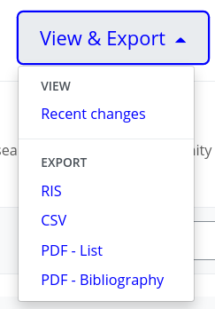
- At top right, go to View & Export (if instead you see View, see step 3)

- Pull down the View & Export menu

- PDF - List will create a PDF with the references in the order they appear on the list. PDF - Bibliography will create one with the references in the order dictated by your chosen referencing style (usually alphabetically by author)

- You can also use the RIS option to create a RIS file of the references, which you can then import into EndNote, or the CSV option to create a spreadsheet for importing into Excel or Google Sheets.

- You may wish to do some tidying up of duplicates – for example, if you have both a print book and an e-book of the same title on your reading list as separate entries, that book will appear twice in the bibliography. This can be avoided by having only the print bookmark on the list, with the “Online Resource” box in the bookmark ticked to give access to the e-book version.

- If any of the references don’t look correct, contact your Academic Liaison Librarian for help, as the metadata in your bookmarks may need amending. Contact details available at https://www.brookes.ac.uk/library/resources-and-services/course-resource-help

