Creating a new reading list in Aspire

Before you start, make absolutely sure your module doesn’t already have a list in Aspire! Use the search box at brookes.rl.talis.com (or the Reading Lists tab in LibrarySearch on the Library home page) and double-check by both module code and module title.
- If you find a list and just need to update it, use the Updating an existing reading list in Aspire guide.
- If your new list is completely different from the module’s old one, contact your Academic Liaison Librarian and ask them to Archive the old list. You can carry on creating the new one in the meantime.

To start creating a new list:
If you don’t already have an Aspire account, see the Getting started with Aspire guide.
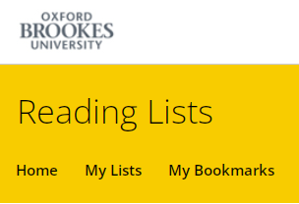
- Log in to Aspire (at brookes.rl.talis.com) with your staff number and password. Click My Lists in the yellow menu at the top.

- Click the Create New List button on the right.

- Fill in as many of the boxes as you can – only List name is compulsory at this stage.
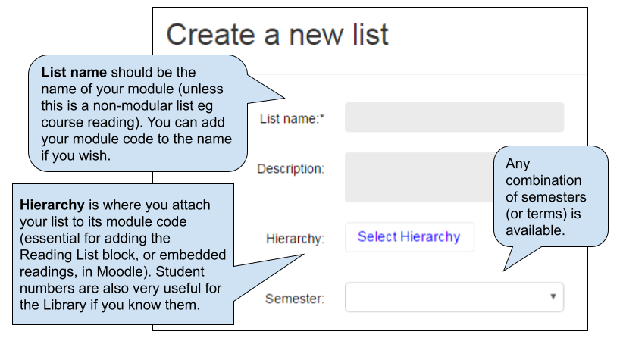

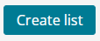
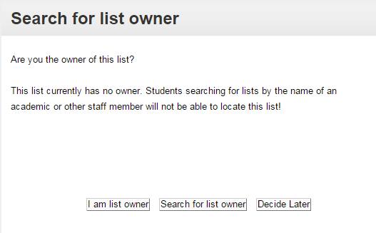
- Then click the blue Create List button.
- You’ll be asked who the List Owner is:
- If you’re the module leader, select I am list owner
- If someone else is the module leader and they also have an
Aspire account, select Search for list owner and add them
- If you can’t find the right person, or aren’t sure, Decide Later

- You now have a new, empty draft list. Start by creating whatever sections you want in it to give it structure (eg by topic, or Key Texts/ Background Reading, or Books/Journals, or Week 1/Week 2 etc…) You add the first section from the Empty List dialogue:

To add subsequent sections, use Add Section on the rolling blue editing bar:

Repeat this until you have your overall list structure. Thinking carefully about how your list is structured is a key way of engaging students with the reading on your module; research shows that students are far more likely to read widely if they can see clearly how the reading you’re recommending is integrated with the module teaching. The Library’s guide What is a reading list for? A guide for module leaders on aligning reading with learning outcomes can help you think through your list structure.
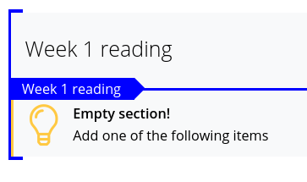
NB: Make sure you are adding each new section above or below the previous section, not within it - it’s easy to “nest” sections accidentally. Check where the blue editing bar is relative to the bold-outlined corners of the adjoining section. When you are within an existing section, the blue editing bar will say so at the left-hand end. If you do want sub-sections, you can create a section within an existing one. Table of Contents at the top shows what you’ve done.

- Once you have your list sections, you can start adding resources within them. Position the blue editing bar where you want to add an item (make sure you are within a section), click ADD RESOURCE and select from your recent Aspire bookmarks; or use the Search box in the Add Resource tool to search Brookes LibrarySearch by author, title or ISBN to find books and journal articles.

(If you want to add resources to your reading list which are not on LibrarySearch - for example: articles from other Library databases; documents freely available online; YouTube videos, etc - you will need to bookmark them first. (For guidance on how to bookmark the resources you want, see our various bookmarking guides.)
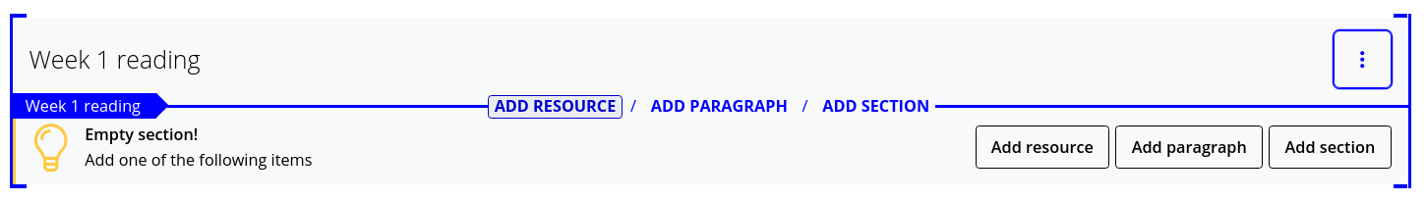
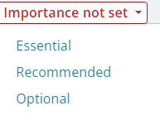
- Use the red Importance flag to indicate to students (and the Library) whether items are Essential, Recommended or Optional.

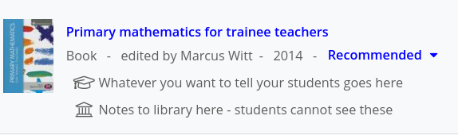
- Use the three-dot menu on the right of each item to access Note for students and Note for library. Student notes enable you to annotate the list. Library notes can be used to communicate privately with the Library about an item (eg to ask if an e-book is available).

- Other options available from the three-dot menu on the right of each item (and section) include moving it up or down, and cutting/pasting (so you can move whole sections to rearrange the list).

- Once the list is complete, you can link it to its module number(s) and add student numbers (if you didn’t do this when you set it up). At the top of the list, select Edit – Hierarchy & Student numbers and enter the details. Then Save.

- Most important of all, when the list is ready, click Publish at the top of the list. Only when you Publish the list is it available for the Library to review and for students to see.

- Once you’ve Published, students can find and view your list from the Reading Lists tab on the Library home page.

- Now check the Aspire guide on Putting your Aspire reading list in your Moodle course. You must embed your reading list in the Key resources section at the top of your Moodle course; you can also embed each section of your list in the relevant week/topic in Moodle, which has been shown to drive increased student clicks on the reading.

- For guides on any other aspect of using Aspire, check out How to use Aspire - guides and help for academic staff (just search for aspire help in the Reading Lists search)

- If you need any 1-2-1 help, contact your Academic Liaison Librarian (find their contact details on the Library Web site at https://www.brookes.ac.uk/library/resources-and-services/course-resource-help)

