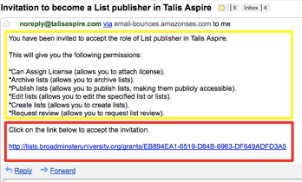
Getting Started with Aspire

- Get invited - have you received and accepted an invitation from Aspire to become a List Publisher?

This comes as an email from noreply@talisaspire.com, with a link you have to click on to accept the invitation. If you’re not sure or need help, contact your Academic Liaison Librarian.

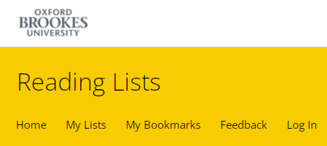
- Go to Aspire – go to the Library home page (www.brookes.ac.uk/library) and click on the Reading Lists tab under Search the Library, then search for a list by name or code. Alternatively go straight to https://brookes.rl.talis.com/

- Log in to Aspire in the top yellow menu with your Brookes staff number and password.

- Fill in your Profile (which should come up automatically the first time you sign in) with basic details like your name, and the fact you are a lecturer, academic, learning technologist, librarian etc as appropriate – these details, apart from your email address which is always hidden, are what appear to students when they search for your reading lists.

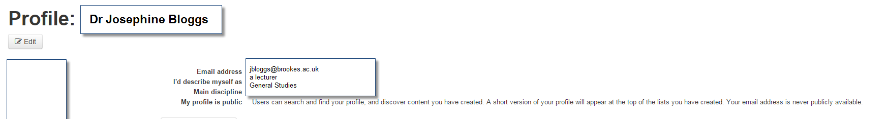

- Set up your Bookmarking tool (you only need to do this the first time you use Aspire on a new computer/laptop/tablet, eg once in your office at work and once on your laptop at home). Instructions on how to do this in different browsers (Chrome, Firefox and Microsoft Edge) are on Talis’s support pages: https://support.talis.com/hc/en-us/articles/360000415058-Installing-the-bookmarklet-extensions-for-Microsoft-Edge-Chrome-and-Firefox- If you are using Chrome, see below:

- Go to the Chrome Extensions Web store at https://chrome.google.com/webstore/ and search for

talis aspire bookmarking
- Click on the Talis Aspire Reading Lists Bookmarking extension
- Click on Add to Chrome (in blue top right)
- Confirm that you want to Add extension
- Right click on the Talis button which now appears to the right of the address box in your

browser (if you already have a lot of extensions installed, it may be behind the Extensions icon)
- Select Options
- Choose Oxford Brookes University from the drop-down list, then Save.

Now you’re set up to start bookmarking items, creating lists, or updating lists – follow the other guides in this series to do each of those tasks.

