Putting your Aspire reading list in your Moodle course

Students can find any online reading list in Aspire just by going to Reading lists on the Library home page and then searching for the module name or code (as long as you have remembered to use Link to Hierarchy in Aspire to link your list to its module code).

However, most students will start from Moodle; so to make sure they can’t miss your list, it should also be included in your Moodle course. You can also embed sections from an Aspire list into individual weekly/topic sections of a Moodle course, which has been shown greatly to increase student clicks through to reading (see the end of the guide).

In the new Moodle 4 template, your whole reading list should be included in the Key Resources section. We recommend putting it just below the module handbook, so students can find it quickly - here’s how:

- Log in to Moodle, go to the module where you want to add the reading list, and look at the Key Resources section. If the reading list isn’t already there, you’ll need to add it.
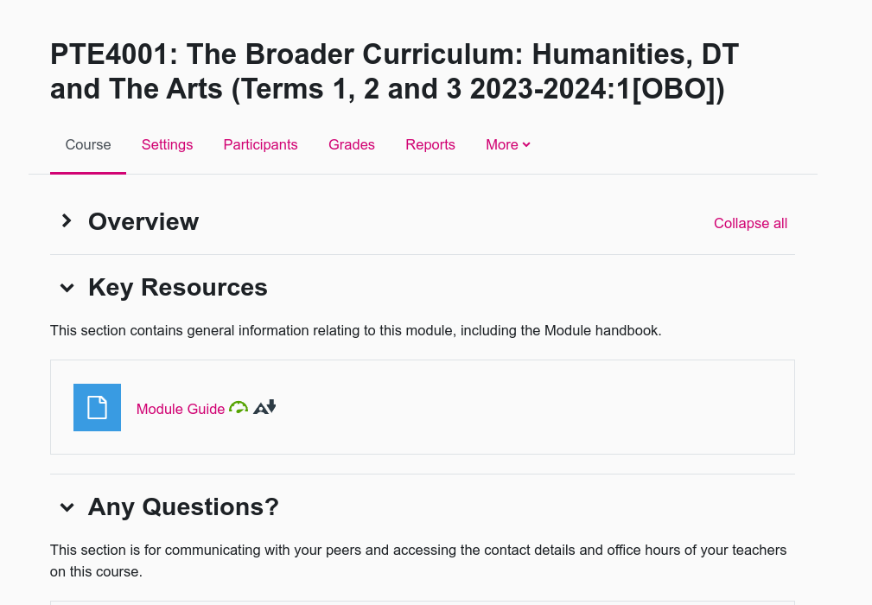

Key Resources section which does not yet contain the reading list.

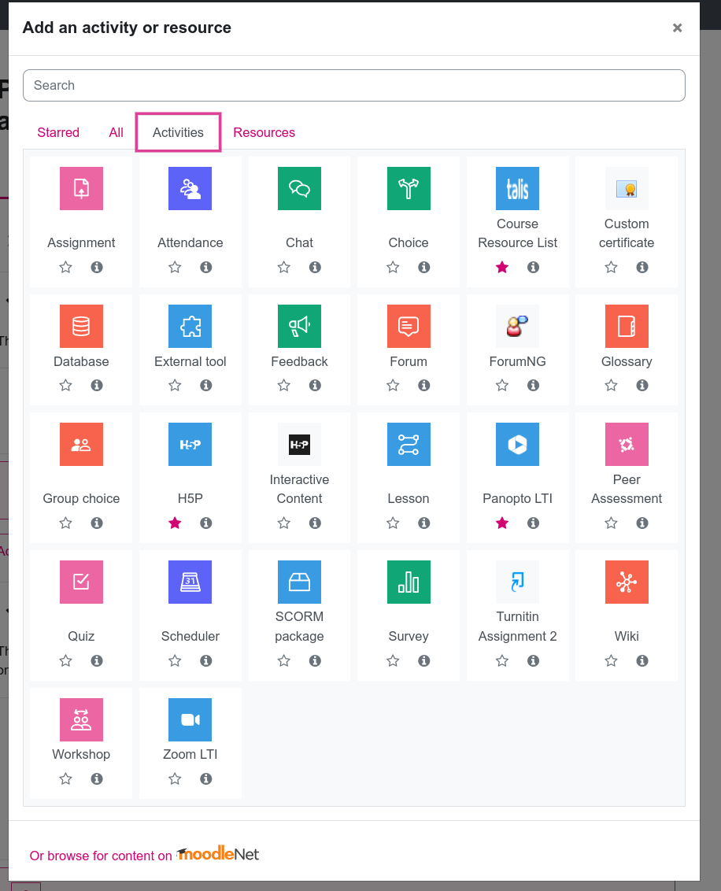

2. Turn Editing on and go to Add an activity or resource.

3. Under Activities, find Course Resource List (with a blue Talis icon). You can star this activity to make it easier to find again (in Starred) later. Click on this activity.

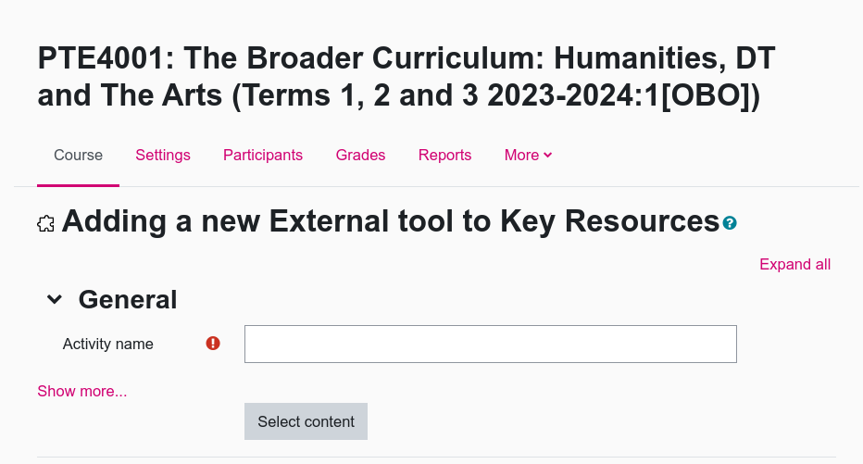
4. Do not fill in an Activity name at this point as this will be overwritten when you add your list.

5. Instead, click Select content.

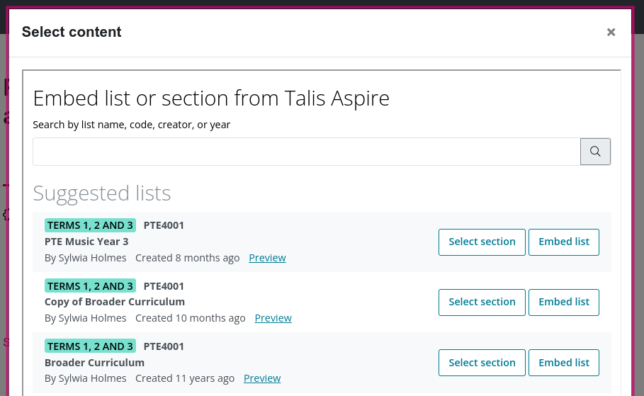
6. Moodle will now look for your Aspire list. If your list is attached to the right module code in Aspire, Moodle should be able to find it automatically. (If you are offered several lists, make sure you choose the right one.) If your list is not offered, you can search for it in the search box.

7. Once you’ve found the right list, click Embed list. (If for any reason you want to embed multiple lists in your Moodle course, you can just repeat this process.)

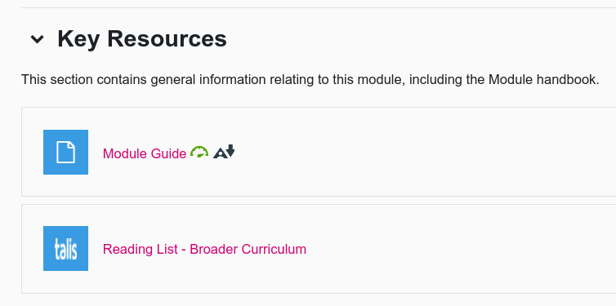
8. The activity will be embedded with the automatic title “Talis Aspire” followed by the name of your list. This won’t mean anything to students, so change the activity name to something like “Reading list” followed by the list name.

9. Save and return to course. You should now see your reading list embedded in Key Resources. Students just have to click on the list to access it.

10. To embed a section from an Aspire list into individual weekly/topic sections of a Moodle course, use the same process but choose Select section instead of the whole list.

