Updating an existing reading list in Aspire

There are thousands of reading lists already online in Aspire, so many module leaders will only need to keep lists updated by removing items they no longer want and adding new ones, updating to newer editions of texts, reorganising the list sections to match how you are teaching the module, etc.

If you have found the existing reading list via your Moodle course, or searched from the Aspire home page (https://brookes.rl.talis.com/ – or go to the Library home page and click on the Reading Lists tab in LibrarySearch) and found that your list already exists, here’s how to update it.

- Make sure you are logged in to Aspire with your staff number and password (your name should appear in the top yellow menu). If you don’t already have an Aspire account, see Getting started with Aspire.

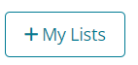
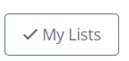
- Find the list you want to update from the search box (if it has a common title, eg Dissertation, make sure it is the right one by checking against the module code!) and click through to it.

- On the list page, at top right you’ll see one of these two buttons; if you see + My Lists, then click it. This adds this reading list to the collection of lists you want to work on.

- Now you can start adding, removing or editing items.
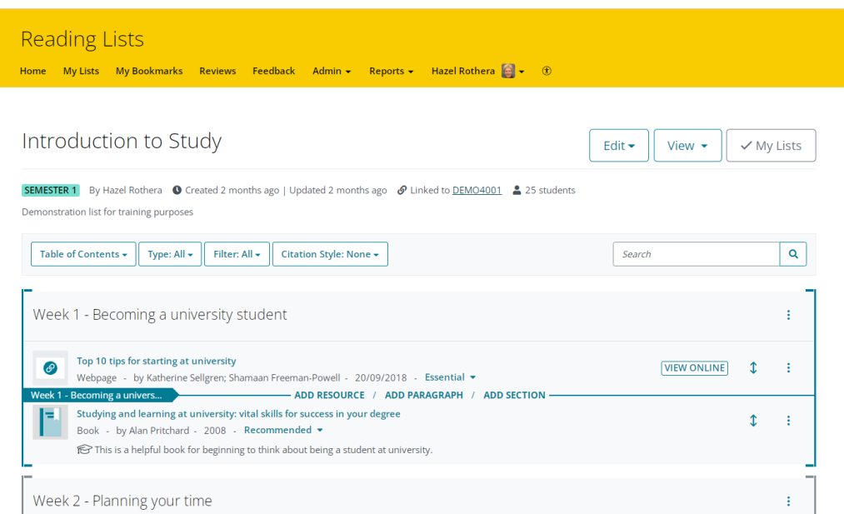

Roll the blue Add bar up or down the list to the point where you want to add a new section, paragraph (of explanatory text for students) or a new resource. A flag at the left-hand end of the blue bar will tell you what, if any, list section you are in. Then click on ADD RESOURCE, ADD PARAGRAPH or ADD SECTION as appropriate.

(To move an entire section, use “Cut” then “Paste” from the three-dots menu on the section title.)
- If you click Add Resource, the Quick Add tool will appear. This will initially show your most recent bookmarks. Use the Search box at the top to search your bookmarks and Brookes LibrarySearch for any book or journal article you want to add.

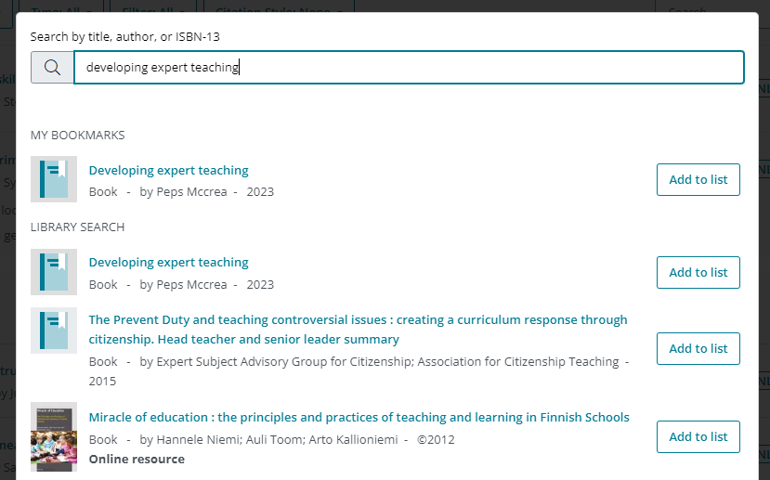
- Click on Add to list next to any item to add it.
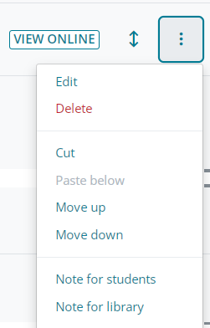
(If you want to add to your list something which isn’t on LibrarySearch - for example, an article that’s only on another Library database, or a report that’s freely available online - you will have to bookmark it before using the Quick Add tool. Refer to the bookmarking guides in this series for help with bookmarking all the different types of resource you might want.)
- Use the three-dots menu to the right of each item (or section) to delete an item, move it up or down the list, or add student notes (eg when/why a student might want to read this) and library notes (which only Library staff, not students will see) such as requests for e-books or for more copies.
- You can also drag items up or down with the double-headed arrow on the right.

- To change the list title, description, semester, module code or anticipated student numbers, click Edit at the top of the list.. List title, description & semester are under “List details”, while “Hierarchy and student numbers” is at the bottom.

- Before Publishing, make the final checks below:

- To see what your list will look like to students, click View – As Student (on the right). Make sure your VIEW ONLINE links work!

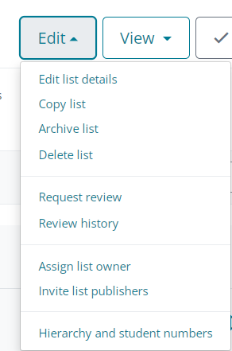
- Does your name appear immediately under the list title? If not, and you are responsible for this list, then you need to make yourself the List Owner. Pull down the Edit menu, choose Assign List Owner and click Assign to me. This means students who search Aspire using your name will find this list.

- Is your list linked to the correct module number(s)? (Look for Linked To under the list title). If not, pull down the Edit menu, choose Hierarchy & Student numbers and add/remove module numbers as necessary, then Save.

- Most important of all, when the list is ready, click Publish (top right in yellow bar). Only when you Publish the list is it available for the Library to review and for students to see.

- Once you’ve Published, that’s it! Students can find and view your list from the Reading Lists tab on the Library home page, and the Library will be alerted to review your changes. You may now want to check the Aspire guide on Putting your Aspire reading list in your Moodle course, so your students can also find your list from their Moodle course (you can also embed individual weekly sections of the list into the corresponding week in your Moodle course).

- If you need any help, contact your Academic Liaison Librarian: find their contact details on the Library Web site at https://www.brookes.ac.uk/library/resources-and-services/course-resource-help

