Advanced Search Techniques

Quick Reminder of basic search techniques:

Truncation and wildcards
teach* - teach, teacher, teachers, teaching optimi?e – optimise, optimize

Search Limits

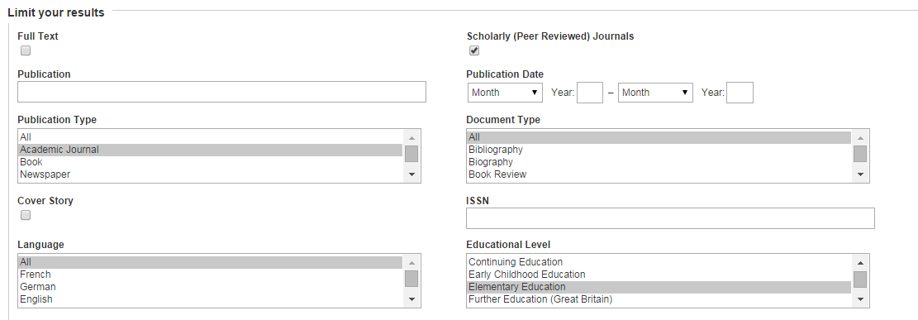

primary or key stage 1 or key stage 2
AND
Literacy or reading

These can include:

Words only in article title (or in abstract, author’s name, etc)
Date of publication
Publication type (eg journal article, book, research report)
Age group or education level
Geography or location
Full-text only
Peer-reviewed journals only
depending on the database.

Thesaurus: to search by subject, instead of by the words the author happens to have used

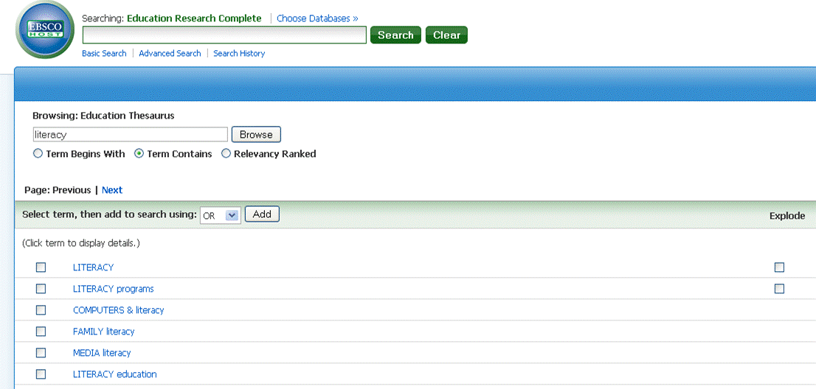

Search History (or Recent Searches) – to combine or amend searches you have just done

Saving searches, creating alerts and setting up RSS feeds:

These are all usually done either from a search results page, or from Search History, depending on the database:

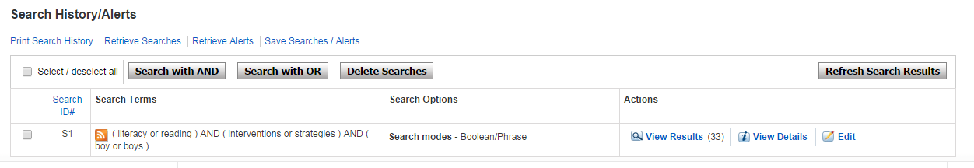

Saving a search means that next time you log into that database, you will be able to re-run the same search without typing it in again. In most databases, you’ll first need to create an account (My EbscoHost in most Education databases – create it once and it will work for all Ebsco databases).

Creating an alert means you ask the database to alert you, usually by sending you an email, each time new articles are added to the database which would match your preferred search strategy.

RSS feeds will proactively push information about relevant articles into an RSS feed reader (so you have to be using one of these already, such as Feedly, Feedreader or directly within your browser).

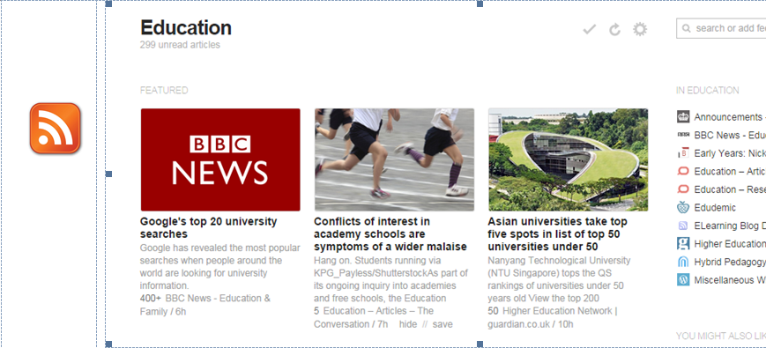

EndNote Web: you can use this software through your Oxford Brookes login to help you keep track of your references and create bibliographies. More details on the Library Web pages:

http://www.brookes.ac.uk/library/library-services/endnote/

