Brookes Library online 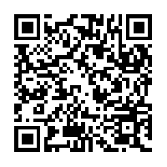
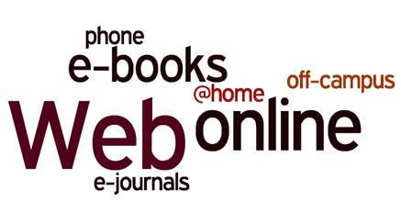

A guide for Education students

E-books, e-journals, reading lists, databases, Web sites, all available from anywhere you have internet access. Save time (no need to come to the Library), save money (we’ve already paid for you) and get better marks (by referring to a wider range of material), all without leaving home! What have you got to lose?

How do I get in?

You’ll be asked to log in to access resources, so you’ll need your Brookes student number and password.

- Start from the Brookes Library home page: go to www.brookes.ac.uk/library
- Choose your tab from the LibrarySearch box:

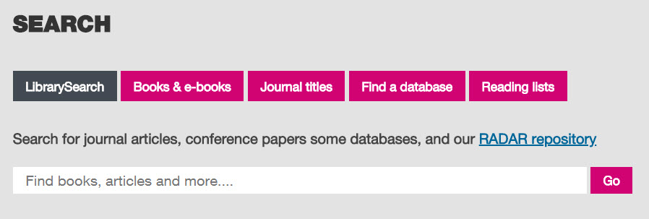

- LibrarySearch (default) to do a general search right across Brookes Library (and beyond) in all
formats
- Books and e-books to search just for books; you can then limit your search to ebooks
- Journal titles to find and browse a specific journal, eg british educational research journal; you
can then limit your search to eJournals (ie excluding journals where we don’t have them online)
- Find a database to search for Education articles in our subject databases
- Reading lists to search for a reading list by the module name or module number

Which tab do I choose? That depends what you want to find…

You can get more help with any of these from the Education Subject Help pages:

- Click on Subject Help (below the SEARCH box on the Library home page)
- From the list of subjects on the next page, scroll down to E and choose Education
- Bookmark the Education/Early Childhood Subject Help page for next time:
http://www.brookes.ac.uk/library/subject-help/education-and-early-years---early-childhood-studies/

I want some general background or introduction to a subject – I want a book:

You probably need to start with a textbook, so you want the Books and ebooks tab on LibrarySearch.

If you need more help, click the ebooks section on the Education Subject Help page for more information, or look at our separate guide Ebooks for Education students on that page. Remember not all our books are available as ebooks, just a selection of key texts.

I want to read a specific journal article I already know the details of:

Use the default LibrarySearch tab and type in the author and title of the article. This will usually bring it up, if we have it available online.

If it doesn’t come up, use the instructions for browsing a journal below to see if we have the journal you want, and then navigate from the journal title to the specific year, volume, issue and article. If we don’t have it, you can ask the Library Helpdesk about getting it from another library (Interlibrary Loan).

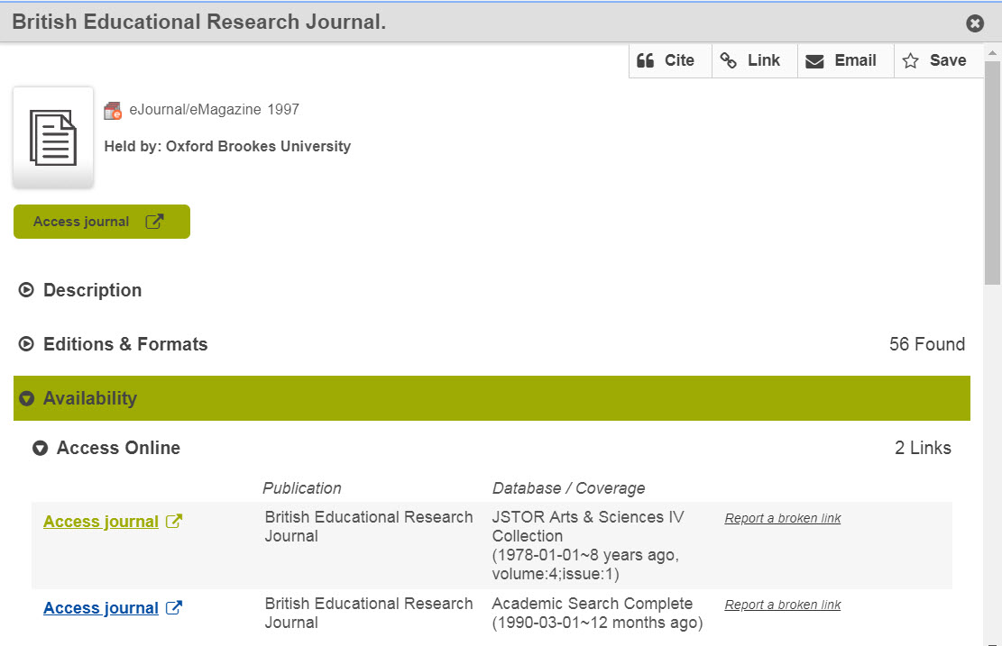I want to browse the articles in a particular journal:

From LibrarySearch on the Library home page, choose the Journal titles tab and then search for the journal title you want, such as british educational research journal (not the title of an article). In the search results, click the title of the journal you want, and then scroll down to Availability.

In the Availability listing, click on an “Access journal” link with coverage including the year you want. (Not all access links cover all years, and not all journals can be accessed online.)

If a login screen comes up, just log in with your Brookes details.

Once into the journal, click through years and issues to the article you want. Most articles are pdf files; you can usually save or print them.

I want to find some research or journal articles on a topic:

You can use the default LibrarySearch tab on the Library home page to search by topic across our print and electronic resources – though this isn’t specific to Education so you will get resources for other subjects as well. You can filter your search results to Article (Format) and Education (Topic).

To do a more focused Education search for articles, you need to use an Education database. These search collections of journal articles and research reports.

Click the Find a database tab on LibrarySearch, and then choose Education from the list of subjects. That takes you to our Education Subject Help page – scroll down to the Databases section.

British Education Index is usually the best place to start, or use the One-Stop Search to search all our Education databases at once. To search, type in a keyword or keywords describing your topic:

literacy difficulties | will find any articles mentioning the phrase “literacy difficulties”
literacy difficulties OR reading difficulties | will find any articles mentioning either phrase
literacy difficulties AND boys | will find only articles that mention both literacy difficulties and boys

The databases have full text for most articles. To ensure you only see articles where the full text is available within the database, you can select Limit To: Full Text in the menu on the left.

I want to find information about an organisation or a current policy document:

If you know a specific organisation or document’s name, you can just do a normal Web search for it. To find out about organisations or policy around a topic, you need a recommended Web site. Click our link to Web sites on the Education Subject Help page, and see if the drop-down menu of topics covers your area, then have a look at the recommended sites. If those don’t help, get in touch with the Education Librarians…

I need help!

… I can’t access the resources:
Make sure you typed your Brookes Login details correctly. If your login is not working for anything (eg Brookes mail, Moodle, PIP) then contact the IT Services Helpdesk. If your login is only failing on Library resources, then please contact the Library (see below)

… I’m in a database but I can’t get to the article I want:
Remember that databases don’t contain full text for all the articles; for some they may just have references and abstracts. To find out whether the whole article is available online elsewhere, look it up on LibrarySearch. Remember also that not all journals, or all issues of a particular journal, are available online; you may have to come and find the journal on the shelves in the Library. Check LibrarySearch for the journal’s title to see if we have it in print.

… I’m having trouble finding journal articles on my topic:
Try working through our search worksheet, Finding journal articles, or watch our video on Finding journal articles with the Education databases, both available under Guides on our Subject Help pages for Education and Early Childhood.

… I need to talk to an expert!
That’s what the Education Librarians are here for – call in to Harcourt Hill Library, phone us
(01865 488220) during office hours, or email us (educationlibrarians@brookes.ac.uk) with a quick query, for help accessing resources from home, or to make an appointment for more in-depth help.

