Database search tips for Sociology

1. Planning your search
This Search Plan for Sociology (Google doc) can help you develop a list of keywords to use when searching online. Click on File - Make a copy - to save your own copy and then add your own notes to it.

2. How do I search a database?
Browse a list of key databases for Sociology students here

Searching with AND
Databases work in a different way to Google and the LibrarySearch. You’ll often see on databases that they have several search boxes linked by AND.
You need to type separate keywords or phrases into each search box, for example:
ethnicity AND employment
attainment AND education
This will find references containing both terms.

Add in additional keywords to focus your search – each new word/phrase will narrow down your search
e.g. ethnicity AND employment AND recruitment

attainment AND education AND social class

Experiment with alternative terms - you may find more results.

Example search on Sociological Abstracts database:

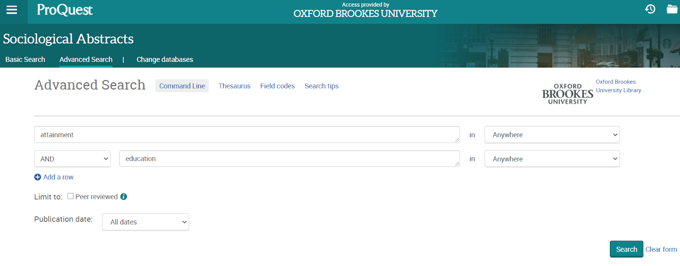

Searching with OR
You can use OR to search for alternative terms and broaden your search, e.g.
employment OR work OR career
attainment OR qualifications OR GCSEs
teenagers OR young people OR young adults OR children.

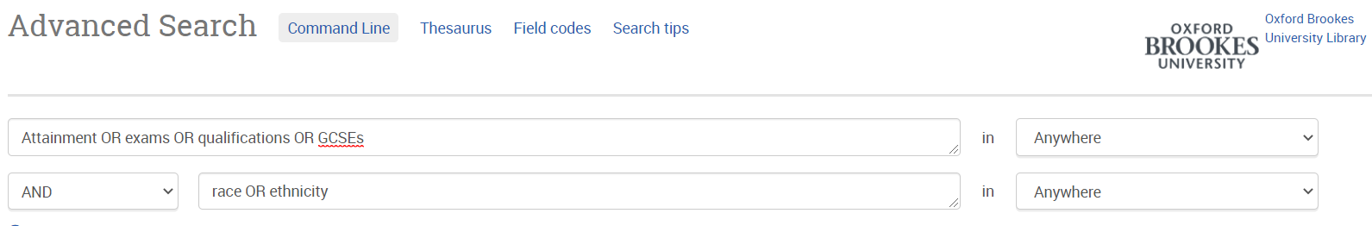
Phrase searching
Put phrases in quotation marks if you want to make sure the words are only found together (and not separately), e.g. “mixed methods”; “social class”; “widening participation”.

Wildcard symbols
- Use the truncation symbol * added to the root of a word to search for alternative endings, e.g. employ* will find employ, employment, employer, employee etc.; ethnic* will find ethnic and ethnicity
- Use the ? symbol to replace a character in a word e.g. sociali?ation will find socialization and socialisation.

Sorting and refining your results
Databases such as Sociological Abstracts and IBSS allow you to sort results by date or relevance. You will probably find that sorting results by relevance is more helpful.
Look for options to focus your search. These can include:
- Limiting your search to material published in English.
- Narrowing your results by date.
- Focusing on scholarly peer-reviewed articles.

3. Further help
- If you would like further help, please contact the Academic Liaison Librarian for Sociology, Joanna Cooksey by emailing jcooksey@brookes.ac.uk
- Check the Course resource help for Sociology at: https://www.brookes.ac.uk/library/resources-and-services/course-resource-help/sociology for links to key-e-resources, guides and much more.

[JC sociologyjournals 08/2020]

