Creating an HTML page in RADAR
- Log in to RADAR
- Click Contribute from the left hand side
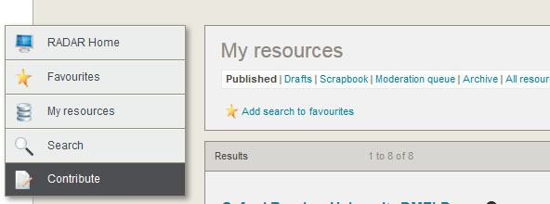
3.
Select which category to put your new resource e.g. Open Educational Resources OER, Faculty
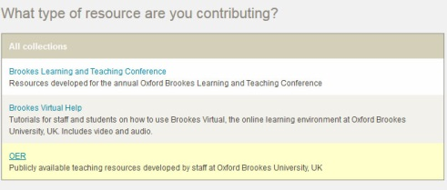
4.Add the relevant details including your name and Faculty etc. CLICK Next.
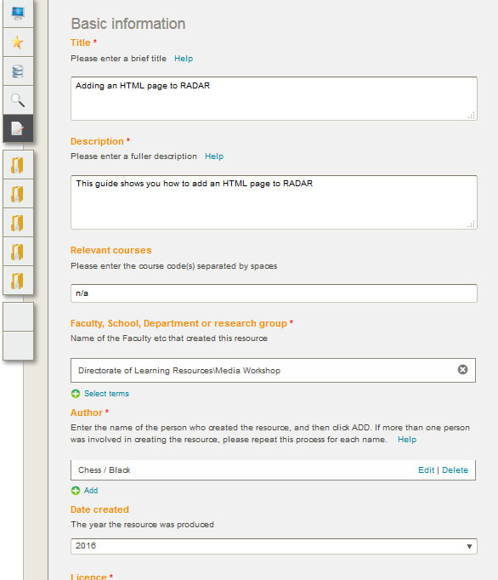
5. Select the type of resource you wish to add, e.g. HTML page. 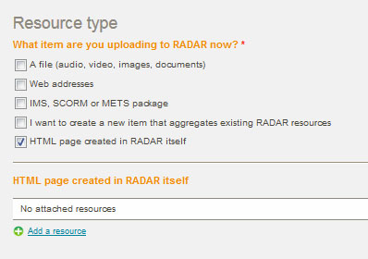
Then CLICK Add a resource to create your html page. 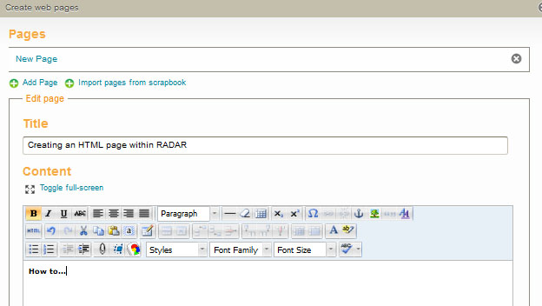
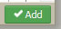
6. Complete the Title, and using the WYSIWYG editor create your html page. From the bottom of the page, Click
7. On the Subject area page, list tick those boxes which are appropriate or relevant to your resource.
8. Add Keywords, Notes and Graduate Attributes as appropriate. CLICK Save.
