Finding art history journals and journal articles

Journals are extremely important sources of scholarly writing; they contain the latest research, scholarship and thinking within a subject area. Articles in journals tend to focus on specific aspects of a subject in much more detail and often cover topics that will not be written about elsewhere.

Journal article references
When you find a reference to a journal article, it will look something like this:

“Beccafumi's Story of Papirius in the National Gallery”
Plazzotta, Carol
The Burlington magazine, vol. 143, no. 1182, pp. 562-566, September 2001

This is what each element of the reference means:
Beccafumi's Story of Papirius in the National Gallery | the title of the journal article
Plazzotta, Carol | the author of the journal article
Burlington magazine | the title of the journal in which the article appears
vol. 143, no. 1182 | the volume and part number
pp. 562-566 | the page numbers
September 2001 | the date of the journal issue in which the article appears

When you have found the journal, you can look for the volume and part number or the year and date, and then you can look for the page numbers given in the reference.

E-journal articles – following up references to specific articles
From the Library web pages select the Librarysearch tab.
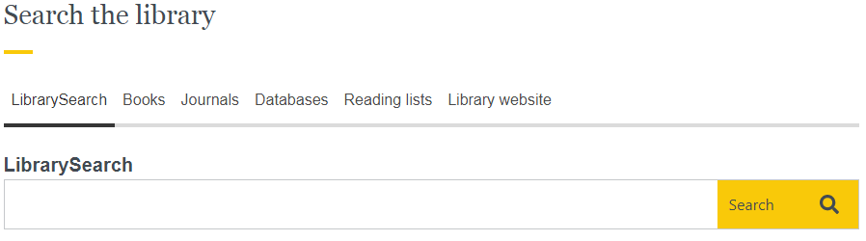

In the search box type in the details of the article (the title, plus the author’s surname).

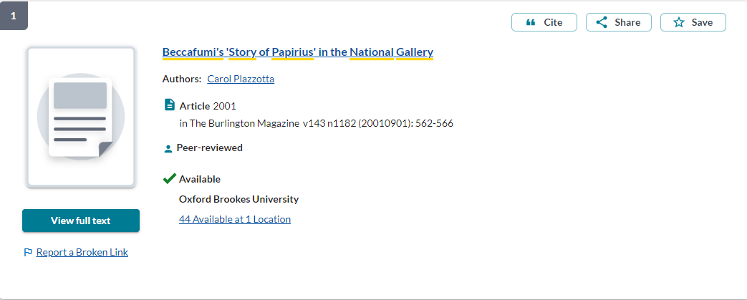

Click on view full text to see an electronic version of the article. The print holdings of the journal are shown below the green button (if available) should you prefer to photocopy the article.

Accessing e-journals
Please try to use links from the Library’s web pages to access our e-resources, as these links may contain additional information which makes accessing that content a much simpler process. Most of the Library’s databases and e-journals will simply prompt you to log in with your Brookes ID and password and once you have logged in you will be able to move to other databases or e-journals without the requirement to log in again during your session.

Which print journals are available from the Library?
- From the Library web pages select LibrarySearch and type the name of the journal into the search box. Click Search.
- Click Details. If there are multiple options, click on the correct journal title
- Scroll down to the holding library name. Note down the call number as this tells you where the journal is on the shelves. Also check the year you want to consult.
- The print journals are in the Journals area of the Basement of the Headington Library, arranged by call number.
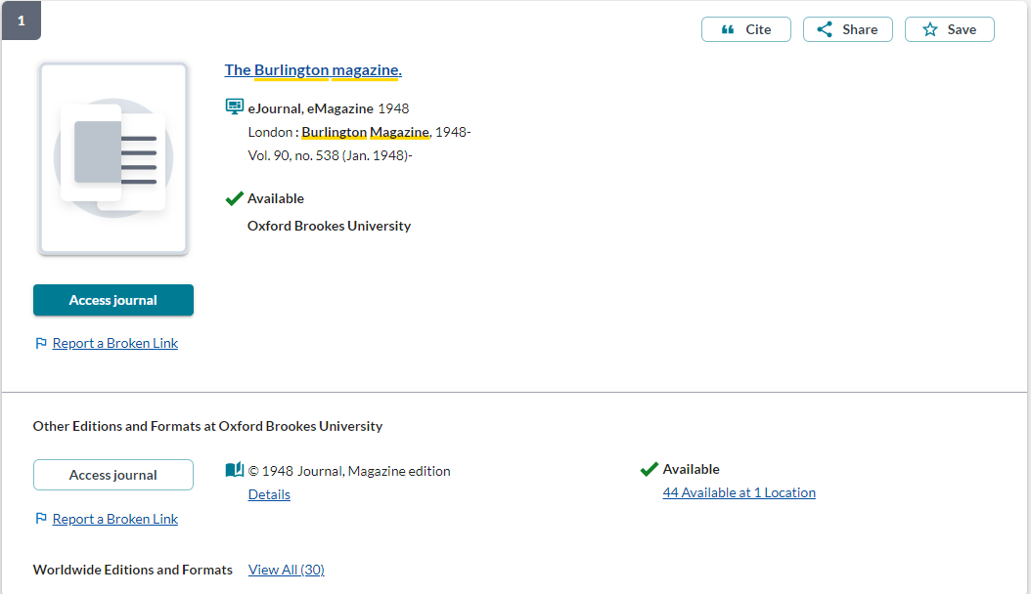

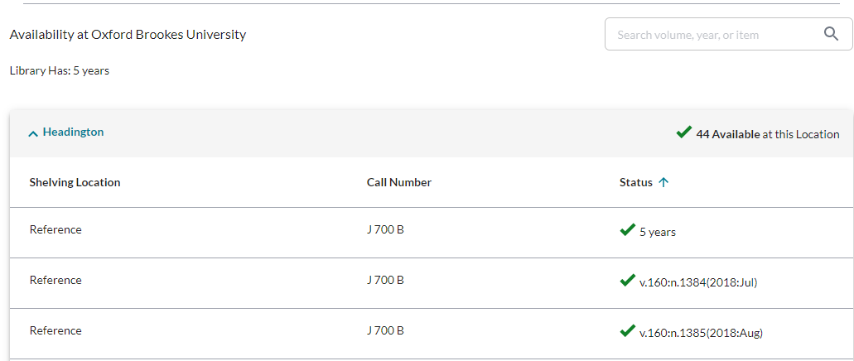

How do I find out what journal articles have been written on my subject?
To find articles on a particular topic or within a certain journal, you can use LibrarySearch or one of the Library’s many online databases. You can get access to these databases from the library art history web pages.

You can search by keywords or subject headings to find references to publications on your topic. Some databases give you direct access to e-journal articles. Other databases will provide you with a list of references to then follow up separately.

Which database should I use?
Art Full Text – includes art and art history e-journal articles from 1997 onwards - it also provides links to other e-journal articles. It is particularly useful for recent journal articles and for journals not covered by JSTOR (for example, Art History and the Journal of the History of Collections). It is also a good way of looking up articles in journals which are not available online (for example, Apollo, British Art Journal). Art Full Text has very good coverage for contemporary art.
JSTOR - this database provides an archive of full-text articles from a wide range of academic journals, including some key art history journals. JSTOR does not give access to articles which are less than 3-5 years old but is very useful for older journal articles.
Bibliography of the History of Art – this free, comprehensive database provides references to art history journal articles and books published between 1975 and 2007.

Architectural publications index - the Library catalogue of the Royal Institute of British Architects; it is strongly recommended for references to books and journal articles on architecture.

How do I obtain articles from journals not available from the Library?
Copies of journal articles not available in print or online from the Library can be requested via the Interlibrary loan service.

More information
There is lots of guidance available on the History of Art Library course help webpage or you can contact your History of Art Librarian, Ashley Cushman, email acushman@brookes.ac.uk or telephone 01865 483146.

3 March 2022

