The London 2012 logo was launched in the spring of 2007, to widespread derision. What does this mean for the future of the Olympic brand?

The official logo of the London 2012 bid appeared to meet with the public approval. It appeared to conform to the general design characteristics of previous Games, identifying clearly that the logo encompassed London, the Olympics and our historic bid for the year 2012.

Why then, did we have to have a new logo that appeared completely different to a logo that the British public had become familiar with, and, actually, quite liked?
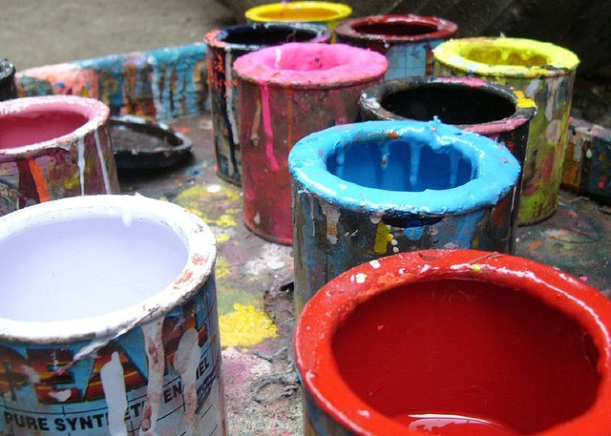
Image created by Murtaza Imran Ali and reproduced under a Creative Commons licence.

THE NEW LOGO
The official logo of the London 2012 Games was met with widespread derision. One Member of Parliament was even upset enough to start an anti-logo petition, gaining over 40,000 signatures within a matter of days! The £400,000 price tag was also widely criticised. To add insult to injury, a promotional video for the logo was then launched, immediately causing epileptic seizures amongst viewers, due to its inclusion of flashing lights. This led to London 2012 removing the offending segment from the promotional video.

DEFENDERS OF THE LOGO
The logo did, however, have some fans. Some brand managers believe that the logo offers a brilliant opportunity to adapt the colours to suit those of any sponsoring brand.

Logo Alternatives

- Would the logo have been designed better by children/young people?

- Should the project have been assigned to young British designers to showcase our great fledgling British talent in the field of design?

- Should we have simply retained the conservative but generally pleasant official logo of the bid team?

FIND OUT MORE:
Miah, A. (2007) No Go Logo?
London 2012’s Branding Hurdle,
Culture at the Olympics, 9(3), 14-17.

CREDITS
© Oxford Brookes University 2010. oxb:060111:007dd

This resource was produced as part of the 2012 Learning Legacies Project managed by the HEA Hospitality, Leisure, Sport and Tourism Subject Centre at Oxford Brookes University and was released as an Open Educational Resource. The project was funded by HEFCE and part of the JISC/HE Academy UKOER programme. Except where otherwise noted above and below, this work is released under a Creative Commons Attribution only licence.

Exceptions to the Licence
The name of Oxford Brookes University and the Oxford Brookes University logo are the name and registered marks of Oxford Brookes University. To the fullest extent permitted by law Oxford Brookes University reserves all its rights in its name and marks, which may not be used except with its written permission.

The JISC logo is licensed under the terms of the Creative Commons Attribution-Non-Commercial-No Derivative Works 2.0 UK: England & Wales Licence. All reproductions must comply with the terms of that licence.

The Higher Education Academy logo and the HEA Hospitality, Leisure, Sport and Tourism Subject Centre logo are owned by the Higher Education Academy Limited and may be freely distributed and copied for educational purposes only, provided that appropriate acknowledgement is given to the Higher Education Academy as the copyright holder and original publisher.



Reusing this work
To refer to or reuse parts of this work please include the copyright notice above including the serial number. The only exception is if you intend to only reuse a part of the work with its own specific copyright notice, in which case cite that.

If you create a new piece of work based on the original (at least in part), it will help other users to find your work if you modify and reuse this serial number. When you reuse this work, edit the serial number by choosing 3 letters to start (your initials or institutional code are good examples), change the date section (between the colons) to your creation date in ddmmyy format and retain the last 5 digits from the original serial number. Make the new serial number your copyright declaration or add it to an existing one, e.g. ‘abc:101011:007dd’.

If you create a new piece of work or do not wish to link a new work with any existing materials contained within, a new code should be created. Choose your own 3-letter code, add the creation date and search as below on Google with a plus sign at the start, e.g. ‘+tom:030504’. If nothing comes back citing this code then add a new 5-letter code of your choice to the end, e.g.; ‘:01lex’, and do a final search for the whole code. If the search returns a positive result, make up a new 5-letter code and try again. Add the new code your copyright declaration or add it to an existing one.

